MADHAVINSTITUTEOFTECHNOLOGY&SCIENCE,GWALIOR
(A Govt. Aided UGC Autonomous Institute Affiliated to RGPV Bhopal) NAAC Accredited with A++ Grade

Chemical Engineering
Date: 23.01.2024

NOTICE
The department is conducting a “One – Day Seminar on Chemical Process Intensification” followed by hands on training on DWSIM software on 24th Jan 2024. The seminar aims to familiarize the students with process intensification methods and practices adopted in chemical process industries. All the students and faculty members should compulsorily attend the same. The details are given below:
Timing:2pmonwards
Venue:DepartmentComputerLab


Prof. Anish P. Jacob
Coordinator
Chemical Engg Dept

One Day Seminar on Chemical process intensification

In accordance with DA/MP/2024/120, a one day seminar on “Chemical process intensification” was conducted for Chemical Engineering students of IInd, IIIrd and IVth Year (In house Project students) on 24th Jan 2024 in Chemical Engineering Computer Lab. The topic of seminar is in accordance with current retrofit processes that aim at integrating two or more technologies to enhance conversion without sacrificing product quality by increasing efficiency, reducing energy consumption, costs, volume, and waste as well as improving safety. The seminar was delivered by Prof Shivangi Sharma; Session 1 includes the strategies of Process Intensification, Examples of PI and importance of educating in Process Intensification in achieving Sustainable Goals
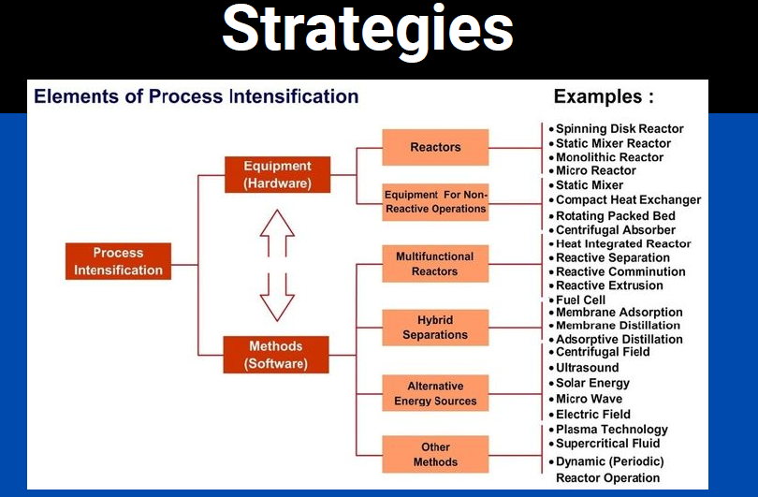
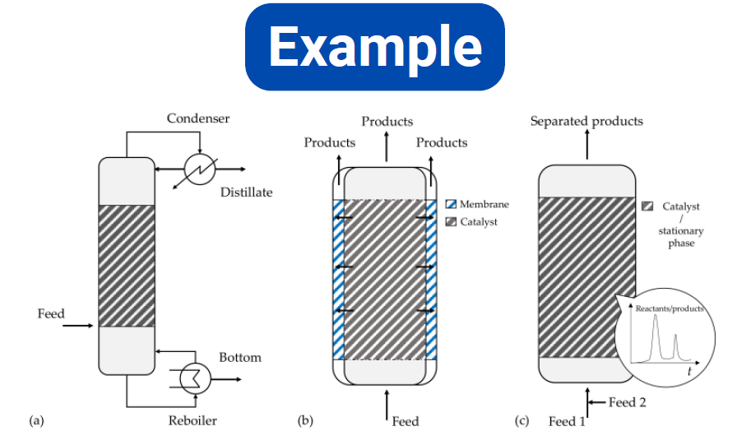
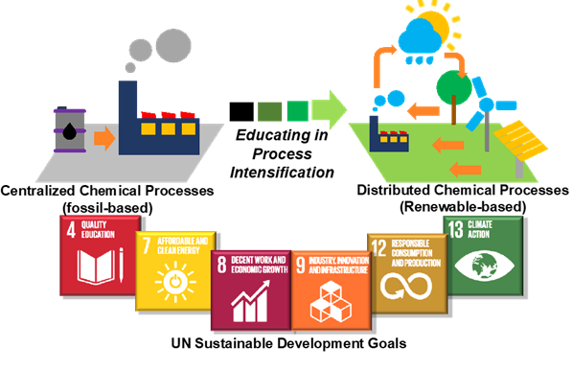
Session 2 was hands-on practise of simulating example of Reactive Distillation as a process intensified technique using DWSIM a CAPE-OPEN compliant Chemical Process Simulator.
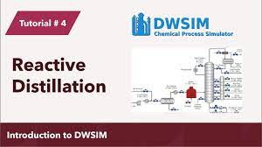
To evaluate the learning outcome assignment and quiz were given on moodle. Also related content is also uploaded.
