NOTICE

In accordance with DA/MP/2024/120, the department is conducting a “One Day Seminar on Energy Saving Technologies in Chemical Engineering” on 11th March 2024 in Chemical Engineering Computer Lab from 4 PM onwards by Prof Shivangi Sharma. Faculties and students of Chemical Engineering ( Ist, IInd, IIIrd and IVth Year- In house Project students) will be beneficiaries.
Kindly adhere to timings and venue.


Prof Anish P Jacob
Co-ordinator
Department Of Chemical Engineering

“One Day Seminar on Energy Saving Technologies in Chemical Engineering”
In accordance with DA/MP/2024/120, a one day seminar on “Chemical process intensification” was conducted for Chemical Engineering students of IInd, IIIrd and IVth Year (In house Project students) on 11th March 2024 in Chemical Engineering Computer Lab. The topic of seminar is in accordance with current retrofit processes that aim at integrating new set of thermodynamically based methods that guarantees minimum energy levels in design of heat exchanger networks. The seminar was delivered by Prof Shivangi Sharma; Session 1 includes the basis of Pinch Technology , Sample Examples of Process Integration by Pinch Analysis.
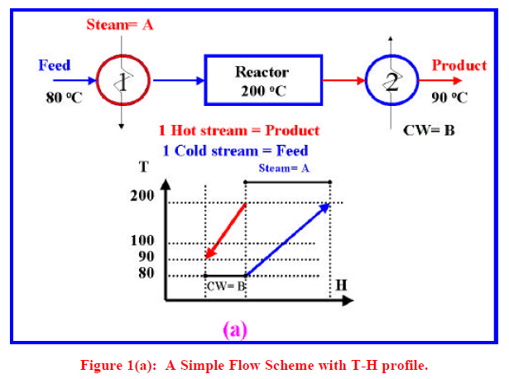
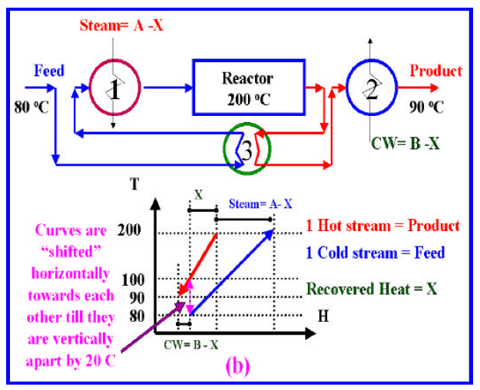
The seminar is followed by details description of steps involved in pinch analysis, Basics of Combined Composite Curves (CCC), and Grand Composite Curves (GCC).
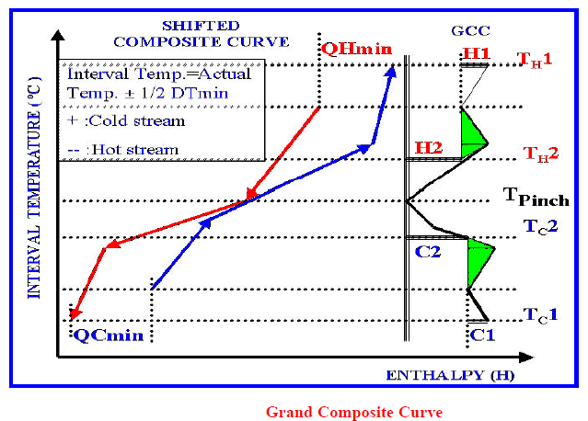
To evaluate the learning outcome assignment and quiz were given on moodle. Also related content is also uploaded.
