Submitted To

MADHAV INSTITUTE OF TECHNOLOGY AND SCIENCE GWALIOR
(A Govt. Aided Autonomous Institute under RGPV, Bhopal (M.P))

IN PARTIAL FULFILLMENT OF REQUIREMENT FOR THE AWARD OF THE DEGREE OF

BACHELOR of TECHNOLOG0059
in

CIVIL ENGINEERING
2018-2022


INTERNSHIP REPORT
ON
“RURAL WATER SUPPLY SCHEME
(JAL JEEVAN MISSION)”
Submitted By–
Saumya Arya
0901CE181096
FACULTY MENTOR
Prof. Anil Kumar Saxena
Dept. of Civil Engineering
M.I.T.S., Gwalior
INDUSTRY MENTOR -
Er Satyam Chaturvedi

Team Leader
P.H.E (T.P.I.) Department
Thatipur, Gwalior
r
Madhav Institute of Technology & Science, Gwalior
(A Govt. Aided UGC Autonomous & NAAC Accredited Inst. Affiliated to R.G.P.V. Bhopal)

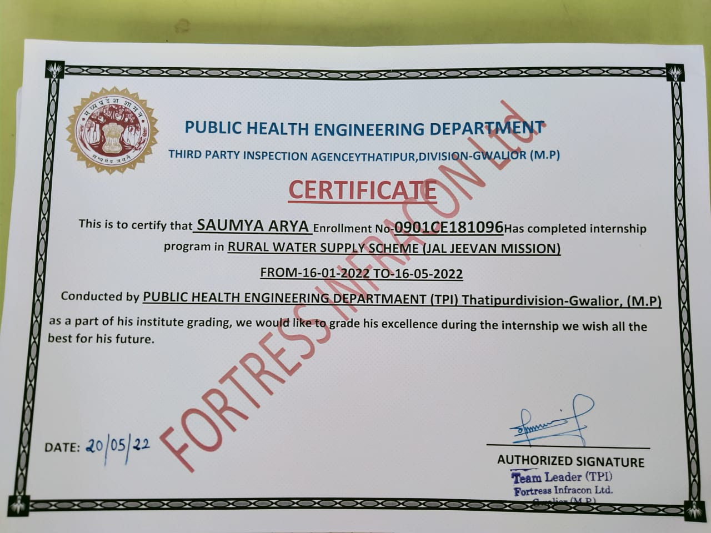

RECOMMENDATION

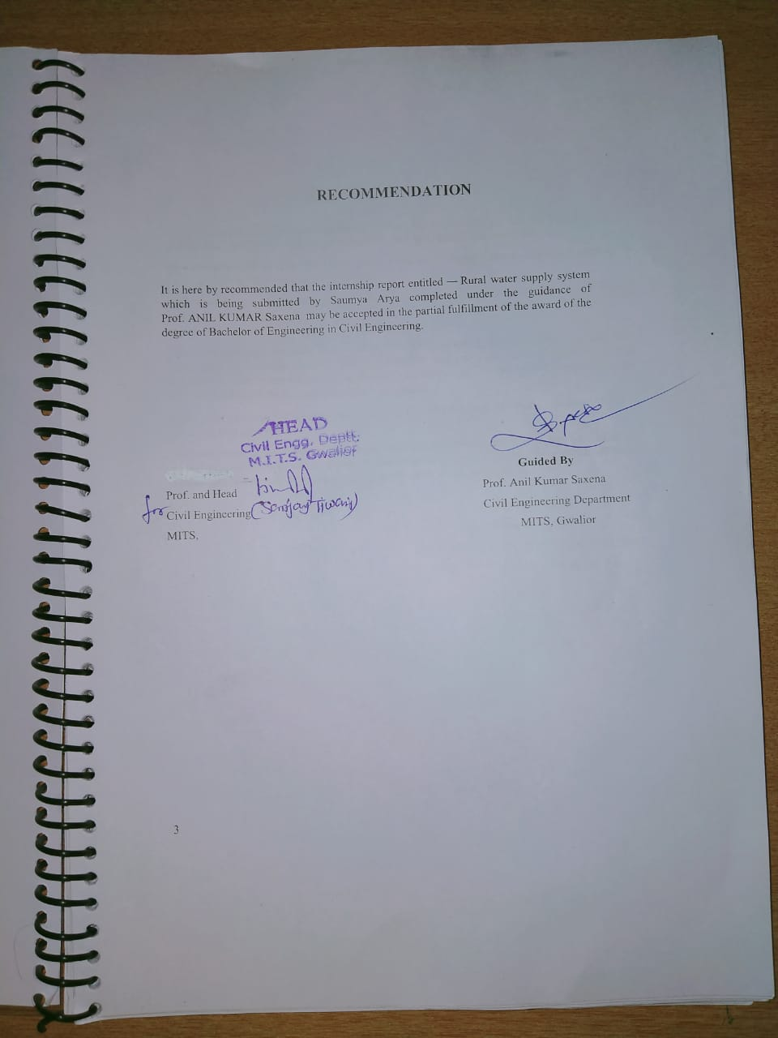

ACKNOWLEDGEMENT
When it comes to properly acknowledging someone's support and assistance, it may be a challenging undertaking, chiefly when the support offered is so wholehearted and unwavering.
I am eternally grateful to my renowned guide, Prof. Anil Kumar Saxena, Assistant Professor of Civil Engineering Department, MITS Gwalior.
Also, I would like to thank Dr. M.K. Trivedi, Head of Civil Engineering Department, MITS Gwalior, and all other academics and staff members of MITS Gwalior's Civil Engineering Department for their unwavering support throughout the project.
I am really grateful to Dr. R. K. Pandit, Director of MITS Gwalior, for establishing an outstanding institutional environment and for giving all facilities and assistance in the preparation of my dissertation. I also acknowledge with gratitude to our supporting Mr. VIKRAM for providing the facilities needed for the accomplishment of this project.
I take great pleasure for my institute P.H.E. (T.P.I) Department Thatipur, Gwalior (M.P.)for providing the opportunities.
The environment of company has been valuable experience for me. It has provided an opportunity to learn at our own pace in discipline of interest. I would like to thank all those who helped me during different stages of completion of this project.

SAUMYA ARYA
0901CE181096
DEPARTMENT OF CIVIL ENGINEERING
MITS GWALIOR (M.P.)

ABSTRACT
Water Supply in India is now previewed as community based demand driven system, under which it is essential to enhance capacity of local
community residing in villages and small towns to develop and manage their own water supply systems.

Role of community groups is to ensure effective and participatory implementation of water supply system in their village/town, water quality control, financial management and effective operation and
maintenance of water supply system established.

The vision of JAL JEEVAN MISSION is Every rural household has drinking water supply in adequate quantity of prescribed quality on regular and long-term basis at affordable service delivery charges leading to improvement in living standards of rural communities.

ABSTRACT IN HINDI

भारत में जल आपूर्ति का अब समुदाय आधारित मांग संचालित प्रणाली के रूप में पूर्वावलोकन किया जाता है, जिसके तहत स्थानीय की क्षमता को बढ़ाना आवश्यक है
गांवों और छोटे शहरों में रहने वाले समुदाय अपनी खुद की जलापूर्ति प्रणाली विकसित और प्रबंधित करने के लिए।

सामुदायिक समूहों की भूमिका उनके गांव/कस्बे में जलापूर्ति प्रणाली के प्रभावी और सहभागी कार्यान्वयन, जल गुणवत्ता नियंत्रण, वित्तीय प्रबंधन और प्रभावी संचालन सुनिश्चित करना है।
जलापूर्ति व्यवस्था के रखरखाव की स्थापना की।

जल जीवन मिशन का विजन है कि प्रत्येक ग्रामीण परिवार को नियमित और दीर्घकालिक आधार पर निर्धारित गुणवत्ता की पर्याप्त मात्रा में किफायती सेवा वितरण शुल्क पर पेयजल आपूर्ति हो, जिससे ग्रामीण समुदायों के जीवन स्तर में सुधार हो।

LIST OF ABBREVIATIONS
O.H.T OVER HEAD WATER TANK
P.C.C PLAIN CONCRETE CEMENT
R.C.C REINFORCEMENT CONCRETE CEMENT
I.S.I INDIAN STANDARD INSTITUTE
MM MILLIMETER
G.L GROUND LEVEL
NGL NORMAL GROUND LEVEL
D DIAMETER
BCM\ Billion cubic metres
WQI Water Quality Index
CPCB Central Pollution Control Board
BIS Bureau of Indian Standards
WHO World Health Organization
EC Electrical Conductivity
TDS Total Dissolved Solids
TSS Total Suspended Solids
DO Dissolved Oxygen
BOD Biochemical Oxygen Demand
COD Chemical Oxygen Demand
mg/l Milligram per litre
mg/l Milligram per litre

CONTENT
Contents
RECOMMENDATION 3
ACKNOWLEDGEMENT 4
ABSTRACT 5
ABSTRACT IN HINDI 6
LIST OF ABBREVIATIONS 7
CONTENT 8
1. INTRODUCTION 11
2. WATER SUPPLY SYSTEM COMPONENTS 12
3. WATER SUPPLY SYSTEM (STANDARD) 13
4. THE IMPURITIES OF SOURCES 14
5. TREATMENT OF WATER 15
5.1. Tests of Many Types 15
5.2. POTABLE DRINKING WATER STANDARD PARAMETER 16
6. Mechanism of Water Supply 17
7. Pump Selection Criteria for Water Supply 17
7.1. SELECTION GUIDELINE FOR PUMP 18
8. Facilities for Storage 19
8.1. ESR (Elevated Surface Reservoir) . 19
8.2. Ground Service Reservoir (GSR): 19
8.3. Sump: 19
9. WATER SUPPLY SYSTEM BASIC PLANNING SYSTEM 20
9.1. VARIOUS COMPONENET IN WATER SUPPLY SYSTEM DESIGN SERVICE LIFE:- 20
9.2. Calculate the Daily Domestic Water Demand in Your Village or Town. 20
9.3. VILLAGE WATER DEMAND ON A YEARLY BASIS 21
9.4. Water Supply Types 21
10. STORAGE TANK C0MPONENTS DURING CONSTRUCTION 22
11. MATERIAL SPECIFICATION FOR CONSTRUCTION 22
11.1. BRICKS 23
11.2. SAND 23
11.3. METAL & STEEL Resulting Reinforcing 23
11.4. CEMENT 23
11.5. WATER 24
11.6. CONCRETE: 24
12. TESTS OF THE MATERIALS LISTED ABOVE 25
13. Criteria For Design Of Reservoir 26
14. Pipe Material Types for Water Distribution Pipelines 27
14.1. Pipes made of mild steel 27
14.2. Galvanized Iron Pipes (GI) 27
14.3. Polyvinyl Chloride 28
14.4. HDPE 29
14.5. Ductile iron pipes 29
15. Pipe Fittings Types 30
16. Laying of Distribution Pipelines 32
17. EXCAVATION of TRENCHES and PIPELINE LAYING and JOINTING: 32
17.1. Preliminary 32
17.2. Excavation and trench preparation for laying underground pipeline 32
17.3. Dewatering 32
17.4. Trench excavation must be done either by hand or by machine. 33
17.5. Preparation of the trench's bottom 33
17.6. In poor soil, a special foundation is required 33
17.7. Blasting for hard rock excavation 33
17.8. Surfaces materials for reuse 33
17.9. Excavated materials stacking and safety provisions 34
17.10. Barricades, guards, and other safety measures 34
17.11. Traffic maintenance and street closures 34
17.12. Structure protection 34
17.13. Trees, fences, poles, and all other Land and Surface 34
17.14. Preparing of Formation for Pipe Line Sections to be Installed Above Ground 34
17.15. Materials in excess of what is required for backfilling 35
17.16. Extra material planning for back filling 35
18. DESIGN AND DRAWING OF 100KL OVERHEAD TANK IN SANKHANI BLOCK BHITARWAR DISTT. GWALIOR 36
19. BHANDOLI SITE VISIT FOR INSPECTION 39
19.1. SUMP WELL OF THE VILLAGE 40
19.2. GSR HAVING CAPACITY OF 125KL 41
19.3. RETROFITTING AND WATER SUPPLY SYSTEM IN BANDHOLI 42
20. Some Laboratory Reports 43
20.1. GEO–TECHNICAL INVESTIGATION REPORT OF GADROLI VILLAGE 43
20.2. Triaxial Shear Test as per IS: 2720 (Pt-XI)-1993 RA-2002 44
20.3. DESIGN MIX M-25 - TEST REPORT 45
20.4. Sieve Analysis of Fine Aggregates Method of Test IS – 2386 2002 ( River Sand) 46
CONCLUSION 49
REFERENCES 50
PLAGIARISM………………………………………………………………………….52
FPR………………………………………………………………………………………53

INTRODUCTION

Water is a necessary component of life and is necessary for the survival of all living things on the planet. Over 700 million people use roughly a third of the world's renewable water supply. Geographically, biologically, and climatically, India is a hugely diversified country. Annual rainfall, including snowfall, averages over 4000 billion cubic meters over the country (BCM). The average amount of natural water available per year from many river basins is calculated to be 1869 BCM.
In India's 14 main river basins, surface tainted water. The monsoon rains fill these rivers, which runs fast. Due to regional and seasonal variations in rainfall, as well as rapid population increase and improving living standards, there is an increasing demand for fresh drinkable water. As a result, the amount of water available to each person is decreasing every day. In India, the former is greater than the latter when it comes to surface water resources and ground water supplies. Increased loads from stated and non-specified sources also affect the quality of surface water as a result of climate change, which has an impact on precipitation.

WATER SUPPLY SYSTEM COMPONENTS
In villages and towns, the water supply system constitues of a gravity-based transmission and distribution system for water treatment from a local or distant water source.

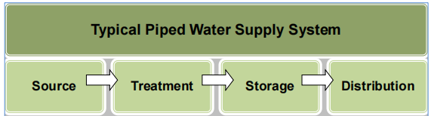
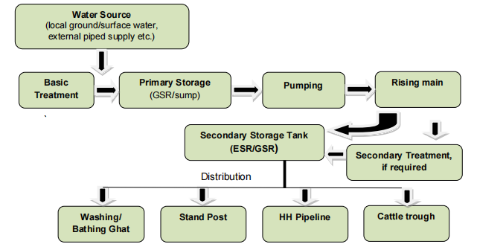

WATER SUPPLY SYSTEM (STANDARD)
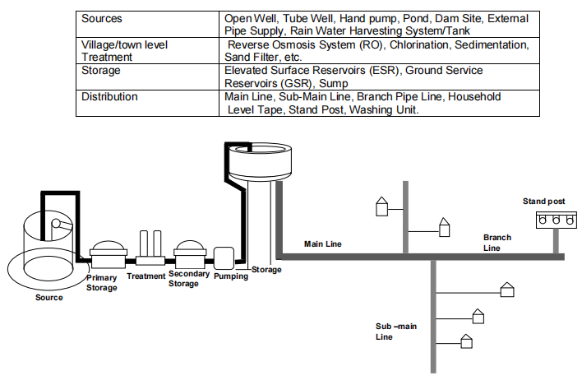

THE IMPURITIES OF SOURCES
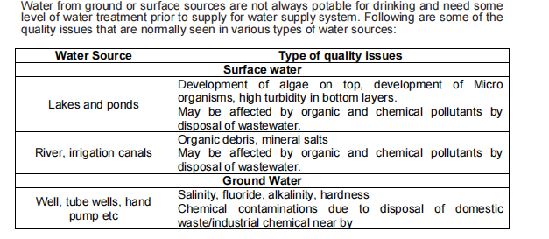

TREATMENT OF WATER
Depending on the quality of the source water that enters the treatment facility, water is treated in various ways in different places. The majority of the water that enters the treatment plant comes from either surface or ground water. Because lakes, rivers, and streams contain more impurity (sand, clay, silt, and other soil particles), pathogens, chemicals, and poisons than ground water, surface water often requires more treatment and filtration than ground water.
Various types of water treatment methods are used in public drinking water systems to ensure that the water is safe to drink. Coagulation, flocculation, sedimentation, filtration, and disinfection are all part of the public water system.

Tests of Many Types
- Temperature, Turbidity, Colour, Taste, and odour are part of the physical test.
- Chemical testing includes pH, Alkalinity, Acidity, Hardness, calcium, magnesium, iron, manganese, Copper, zinc, aluminium, sulphates, florides s, chlorides, nitrates, total dissolved and suspended particles,
- Bacteriological examination for microorganisms such as coliform and E-coli.

POTABLE DRINKING WATER STANDARD PARAMETER
The following are some of the parameters for potable drinking water that are recommended by the Indian government (IS:10500-1991):
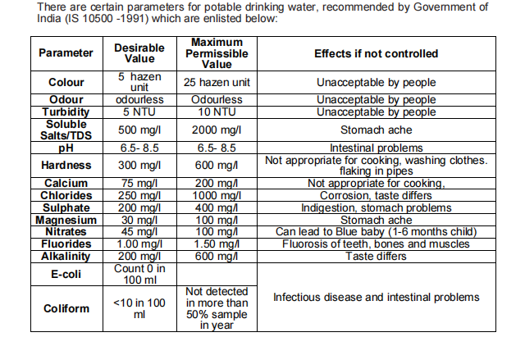

Mechanism of Water Supply
Pump House and Pumping Machinery: A pump is required to carry water from a bore well, an well, a sump, or a groundwater storage tank to pipelines or an elevated storage tank. The following are the three main components:
- The Pump
- The Electrical Or Oil Engine
- The Panel Board. Pump Houses Are Built For The Machines' Security And Safety.
The rising main is the delivery line that carries water from the pump to the storage tank .

Pump Selection Criteria for Water Supply
  - Whether continuous, intermittent, or cyclic pumping is required.
  - Current and future demand, as well as demand change patterns.
  - The required head and flow rates information.
  - The type of power supply and how long it will be available.
  - Choose the pump's operating speed and correct drive/driving gear.
  - The effectiveness of the pumps and the impact on power uses and operating expenses as a result.

SELECTION GUIDELINE FOR PUMP
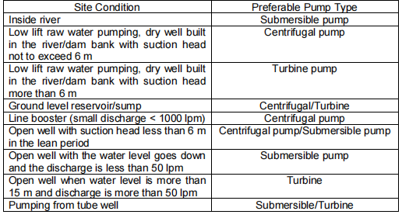

Facilities for Storage
A type of raised storage tank is the

ESR (Elevated Surface Reservoir) .
An ESR is erected where water is to be provided at a high elevation (less than that of the level of the ESR) and where the distance is considerable and the topography is not consistent. It should be erected at a minimum height of 15 metres. Water could be distributed directly via this storage reservoir whether force or a pump is used.

Ground Service Reservoir (GSR):
The abbreviation GSR refers for ground storage tank. In certain circumstances, the water level is less than 3 metres.

Sump:
At the town or cluster level, sump is a sort of storage. It isn't utilised for water distribution directly. It is used to hold water before being pumped to ESR/GSR for intermediate or backup storage. The sump is a dome-lined underground storage tank that is circular in shape. A sump's capacity is often more (and one a half or two times) than an ESR or GSR's amount of water supply, ensuring that people can have access to clean drinking water even though the supply is cut for that time.

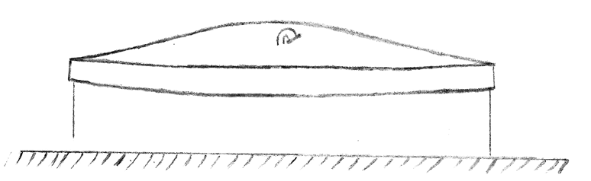

WATER SUPPLY SYSTEM BASIC PLANNING SYSTEM

The following requirements should be met while designing a rural water delivery system:
    - A minimum of 70 lpcd of water supply with house tap connections;
    - A minimal of 55 lpcd for the mix network with HH tap feed + public pipes + handpumps.
    - At least 40 lpcd if no alternative source, such as a hand pumps, open wells, or ponds, is available. Such locations can benefit from a variety of sources.

VARIOUS COMPONENET IN WATER SUPPLY SYSTEM DESIGN SERVICE LIFE:-

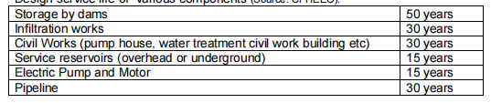

Calculate the Daily Domestic Water Demand in Your Village or Town.
For villages and towns, the government has set a standard of 40-135 lpcd. By multiplying this demand by the number of persons living in the village/town, the total daily consumption may be calculated.

VILLAGE WATER DEMAND ON A YEARLY BASIS
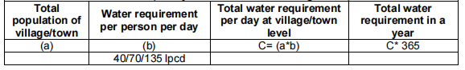

9.4. Water Supply Types
a. Continuous
This system has a continual supply of water (for 24 hours). If there is enough water available, this is possible. The main advantage of such a design is that water stays fresher longer due to constant flow, and pipes rusting is reduced. If it is a leak, however, water losses will be larger.
b. Occasional
Water is either supplied all across village/town for fixed hours, or it is divided into zones, each receiving water for particular minutes in the day or on a specified day.If there is a shortage of water, this approach is used; however, in some condition , Water is squandered as a result of the community's habit of storing extra water than is required. Because of the soaking and drying, pipes in such a system are more prone to rust. During occasions since there is no supply, on either hand, maintenance is straightforward.

STORAGE TANK C0MPONENTS DURING CONSTRUCTION
      - At reinforcing meridians and latitudes, the upper dome is typically 100 millimeters to 150 mm wide. The l/ 5th of the length is usually the climb.
      - The dome isheld by a ring beam. The horizontal portion of the dome push must be absorbed by the ring beam. The ring will be altered to fit the size of the hoop that will result.
      - Cylindrical walls should be constructed to prevent hoop friction produced from horizontal hydraulic pressure.
      - A ring beam formed by the joining of the cylinder and circular walls.This steel plate is designed to resist the horizontal portion of a round wall reacting against a cylindrical wall. The ring beams will be built with hoop tension in mind.
      - Conical slab: Due to water force , this slab will be constructed for hoop thick .The slab will be created as a continuous slab stretching from the top ring beam to the bottom ring ring.
      - The tank's very bottom. It is possible for the floor to be spherical or contoured. This slab is held in place by a ring belt.
      - Ring belt: It is a support system for the reservoir and its contents. The belt will be supported by column and should be built for the bending and torsion moments.
      - Columns: Columns must be constructed to handle the overall load they will be carrying. Columns would be bound at regular intervals and it should be built to withstand compressed air or seismic pressures.
      - Foundations: All supporting columns have a combined foot. After that, it's typical to build a base with a ring bands and a slab around it.

MATERIAL SPECIFICATION FOR CONSTRUCTION
The provisions of Part-IV of the National Building Code of India and relevant-IS Codes of specifications with the most recent changes should control the materials used in construction.
        - BRICKS
        - SAND
        - REINFORCEMENT WITH METAL AND STEEL
        - CEMENT
        - WATER
        - CONCRETE

BRICKS
• The amount of water absorbed should not exceed 15%.
• Bricks must comply with IS 1077, with the most recent revisions.
• Bricks are 9" x 4.5" x 3" in standard size.
• Make use of first-class brickwork.
• Over-baked or less baked bricks can be avoided.
• Cracks, chips, faults, and stone should be avoided in bricks.
• Bricks should have a compressive strength of at least 35 kg/cm2.
• Use frog-themed bricks.

SAND
• The sand shall conform to IS 383/1970. (latest edition).
• Sand from the Narmada River may be preferable.
• The plaster sand should conform to IS 1542. (latest edition).

METAL & STEEL Resulting Reinforcing
• The metal shall conform to IS 383/1970.
• Steel for reinforcement must meet BIS specification 1786/2008 including all current modifications, as well as BIS 1130/1966.
•All steel with a diameter of 8 mm or greater must be cold steel twist distorted bar Fe-415 or TMT steel.

CEMENT
  - Grade 43/53 Ordinary Portland cement shall be utilised in the work. • PPC according to BIS 8112/1989, 12269/1987, or IS 1489 or suitable IS code Ordinary Portland.
- Rapid Hardening Cement will be used for underwater concreting.

WATER
Water for building purposes must comply with IS 456:2000.

CONCRETE:
• In general, concrete should be constructed according to the current version of IS 456:2000, and water-retaining buildings should be planned according to the latest editions of IS 3370.
• All components that come into contact with water must be at least Grade M-30. Unless otherwise specified, any other component not in exposure to water must be of minimal M-25 grade.
• In practice, the clear covers to reinforcement shall be in accordance with IS 456:2000, but characteristics cover shall be given on all water-retaining faces of structural members in accordance with IS 3370. The concrete must be made according to the mix design.
• All concrete ingredients must be weighed and dissolved according to the mix design. If needed, weigh batching can be changed to matching volume batching.
• Only use a concrete mixer to mix the concrete and a concrete vibrator to compact it.

TESTS OF THE MATERIALS LISTED ABOVE
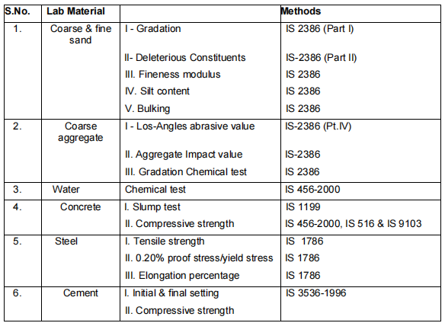

Criteria For Design Of Reservoir
(a) The Foundation must be developed according to the S.B.C. of the soil, as determined by a plate load test or other standard test, as well as other soil parameters.
(b) Take into account the following loads and forces: (i)Dead load
    - Live Load – dynamic and static load owing to water flow and dropping
- Load related to water
- Wind pressure according to IS 875-1987
- Some other loads as required by the applicable I.S.Code. (vi) Pressure owing to Earthquake, i.e. seismic force
(c) Joints in construction
Clause 13.4 of IS 456.2000 should be followed. Before casting the next layer of concrete, the previously built concrete surface should be cleaned with a water jet and a 10mm thick coating of cement mortar of the same proportion laid. The scaffolding should be 100 mm below the concrete layer that has already been placed.
(d) Steel: For design purposes, the minimum steel shall comply with IS 456:2000 and 3370 (Part I to IV) includes current revisions.
(e) Steel type: Reinforcement cold twist steel according to IS 1786-2008 is preferred. TMT is another option.

Pipe Material Types for Water Distribution Pipelines

Water supply systems use a variety of pipes, include metallic and non-metallic piping system. The following are the most frequent types of pipe used in water supply systems:
  - Metal Pipes Made of Mild Steel
  - Galvanized Iron Pipes - this is a metal pipe that has been galvanised.
  - Poly Vinyl Chloride (PVC) pipes (non-metallic)
  - Non- metal High Density Poly Ethylene Pipe
  - Ductile Iron Pipe
For water main, GI and MS pipe, as well as big HDPE pipes, are typically utilised, whereas for branch/service pipes, galvanised and HDPE/PVC pipes are most commonly employed. Both purposes are served by DI pipes.

Pipes made of mild steel
• Because there are fewer joints, it is obtainable in longer lengths.
• Pipes are long-lasting and can withstand high internal water pressure, making them ideal for long-distance high-pressure pipes. • Adjustable to lay for certain curves
• It is lightweight and portable. The amount of damage caused by transportation is minimal.
• Pipes might be corrosion resistant and require more care.
• Repairs take longer, and they're not ideal for distribution piping.
• They come in diameters of 150-250 mm and cut lengths of 4 - 7 m for water delivery (2.6-4.5 mm wall thickness).
• Flanged joints or welds are used to unite steel pipes.

Galvanized Iron Pipes (GI)
• Low costs and light weights.
• Lightweight & simple to assemble.
• Alkaline or acidic water affects it. GI pipes are ideal for use in distribution systems.
- Due to the thickness of pipe utilised, accessible in light (yellow colour code), moderate (blue colour code), and heavy (red colour code) grades.
- For water delivery systems, moderate quality pipe (wall thickned 2.6-4.8 milimetre) is typically employed.
- Pipes with a nominal internal diameter of 15-150 mm are commonly utilised in distribution systems.
- It is available in 3 m lengths.
- GI pipes may be used in non-corrosive water with a pH more than 6.5.
- GI pipe is employed in both the rising main and transport channels. GI pipes are frequently joined at the threaded end with lead putty.

Polyvinyl Chloride
• Affordably priced and low in weight.
• Cost-effective in terms of laying and jointing.
• They're made up of stiff pipes.
• Extremely long-lasting and appropriate for distribution
network.
• Corrosion-resistant and resistant to abrasion a chemical assault
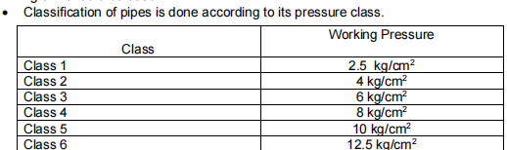
• Excellent electrical insulation.
• They are ideal both distribution piping & branch plumbing.

HDPE
- It is light in weight.
- It is Flexible compared to PVC pipes.
- The colour of HDPE pipes is black.
- Acceptable in subterranean plumbing & able to handle severe traffic movement.
- Allows water to flow freely.
- Exceptionally long-lasting and appropriate for use in a distribution network.
- Corrosion-resistant.
- Exceptional electrical insulation.
- They are useful for water transportation since they are non-toxic and do not foster microbial development.
Groundwater supply and distribution systems typically use pipes with a diameter of 20-315 mm and a pressure of 6-10 kg/cm2. Small diameter coils are available. Obtainable in lengths starting at 6 m for diameters more than 110 mm.

Ductile iron pipes
• Castings pipe are a higher-tensile-strength version of casting iron pipes.
• The centrifugal cast process is used to create DI pipes.
• These pipes offer good internal and exterior corrosion resistance, impactful resistance, High wear - and - tear resistances, High strengthS, ductility, and higher impact resistances.
• The interior surface of DI pipes is lined with cement mortar, which creates a smooth finish and is appropriate for offering physicochemical barriers to water. These pipes help to keep water clean.
• Bitumen or zinc paint is used to coat the outside of these pipes.
• Ductile iron pressure pipe are available in diameters ranging from 80 to 1000 mm and lengths ranging from 5.5 to 6 metres.
• They weigh around 30% less than traditional cast iron pipes.
• Because DI pipes have less frictional resistance, they cost less to pump.

Pipe Fittings Types
Pipes and fittings are essential for pipelines because they join pipes and prevent leaks. For multiple distribution piping systems, different pipe fittings are employed.
a. Socket & coupling - A socket or coupling is a pipe connector that connects two linear lengths of pipe. After threading, the outward diameters of the pipes will be identical to the inner diameters of the socket.
b. Elbow - It joins two pipe of a same dia at the a 90-degree angle.
c. Tee – it will be fit two consecutive pipe and has a right-angle outlet.
d. Union - A union is a fitting that connects the ends of pipe that cannot be twisted. They're employed near all appliances and along stop valves on a long stretch of pipe at the start of a pipe supplies.
e. Reducer - A reducer is a device that connects two pipes of different sizes (diameters) to reduce pipe size. According on the distribution network requirements.
f. Nipple a tubular pipe fitting that is commonly available in 300 mm lengths. It's used to make pipelines longer.
g. Plug - This is a device that is used to stop the stream of fluid at a dead end.
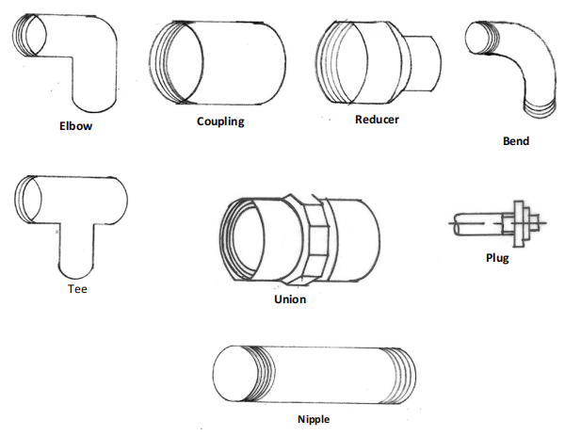

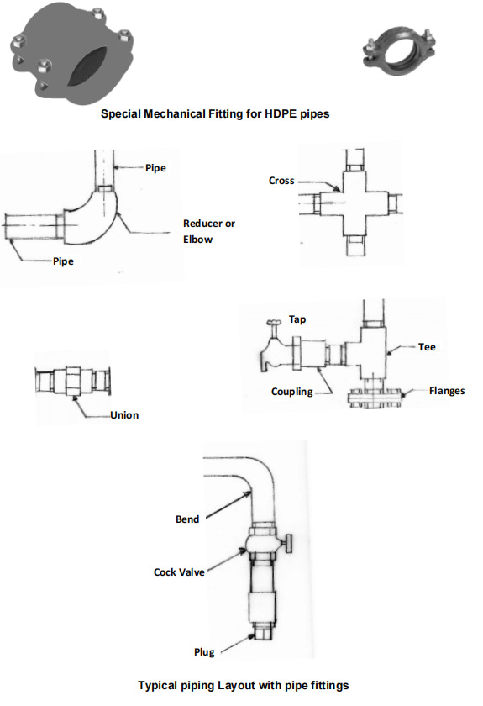

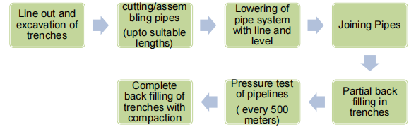
Laying of Distribution Pipelines

EXCAVATION of TRENCHES and PIPELINE LAYING and JOINTING:

Preliminary
Before installing the pipes, a thorough map of the area with alignment, sluice valve, scour valves, and air valves is required. The pipeline could be installed just on side of a road where there is a high concentration of people. Pipes are buried with a minimum of 0.90m of cover on the pipe wall. Before beginning the excavating of trenches for pipeline laying, all plants, grass, large and small plants, trees, , and rubbish from the path must be pegged out, cleared, and disposed of.

Excavation and trench preparation for laying underground pipeline
The trench must be dug in such a way that the pipe may be installed in the specified alignment and depth. A required cover of 1.0 m must be given where the network is under a roadway; otherwise, a least cover of 0.90 m just above top of the pipe must be provided. Wherever possible, the trench should be shored and maintained dry so that the workers can work safely and efficiently.

Dewatering
Wherever necessary, the contractor will perform dewatering. The discharge from trench dewatering pumps must be directed to drainage systems or natural drains and must not be permitted to spread over the work area.

Trench excavation must be done either by hand or by machine.
The trench width must be reduced to a minimum in order to provide adequate working area. There must be a minimum of 200 mm space on both sides of the pipe just at bottom, between both the faces. For adhesive bonding, additional width should be provided at socket and flange places. The depth of the pit at such locations must also be adequate to permit for joint finishing. This is due to the trench's safety, the process of laying & jointing the pipe, and the requirement to avoid pipe coating damage.

Preparation of the trench's bottom
The trench's bottom must be correctly cut to allow for even layering of the pipeline. The curve of the trench bottom should mirror the arc of the pipes as closely as possible, forming a 360o angle at the pipe's centre. Where rock or large rocks are encountered, the trench must be reduced to a depth of approximately 100 mm underneath the level at which the pipe's bottom will be laid, and then filled to the same depth with noncompressible material such as sand, crusher dust, or moorum of sufficient depth to provide curved seating. The pipe trench shall be beddinged according to the IS: 12288- 1987 standard of usage and Installing of High strength Iron Pipes.
  - In poor soil, a special foundation is required
when the trench's bottom is exposed. If a suitable foundation again for pipe, comprised of piling, timbers, or other materials, is found to be unstable to the step where it could be easily removed with an approved material properly compacted in order to support the tubing properly, an appropriate foundation for the pipe, comprised of piling, timbers, or other materials, shall be constructed under the position of the Engineer-in-Charge.

Blasting for hard rock excavation
Blasting for excavation is only permitted if the worker obtains the necessary authorization and takes all necessary procedures to protect people and property. The Engineer-in-Charge will determine the blasting hours, and the blasting technique will be in accordance with the licencing authority's requirements. Excavation blasting that is not needed will be filled with 1:4:8 cement concrete. The contractor will be responsible for making his own arrangements for obtaining and storing the explosives required for blasting.

Surfaces materials for reuse
All material surface eligible for usage in restoring the surface, in the view of the Engineer-in-Charge, shall be kept apart from the general digging material as ordered by the Engineer-in-Charge.

Excavated materials stacking and safety provisions
All excavated materials must be stacked in such a way that they do not harm the work and do not obstruct footpaths or roads. Water tanks under stresses, surface boxes, and fire or other energy controls must be left unhindered and available until the work is finished. Gutters must be kept free or other adequate arrangements for street drainage must be established, and natural water streams must not be impeded.

Barricades, guards, and other safety measures
To safeguard people and property from harm, suitable barriers, construction markings, torches, red lanterns, and guards, as needed, must be erected and preserved during the construction process and until the roadway is safe for vehicles to use. When visibility is poor, any materials, piles, equipment, and pipes that may hinder traffic must be surrounded by fences or barriers and protected by sufficient lighting. The local authorities' norms and regulations governing safety provisions must be followed.

Traffic maintenance and street closures
Work must be done in such a way that it produces the least amount of traffic disruption, and the street may be shut in such a way that it produces the least amount of traffic disruption. Where traffic must over open pits, appropriate bridges must be constructed. It is required to post appropriate signs stating that a roadway is closed, as well as necessary detour/diversion signs, in order to maintain traffic flow.

Structure protection
Under the advise of the Engineer-in-Charge, temporary supports , suitable protections , and guards of subsurface and surface structures, drains, sewers, and other impediments encountered during the course of the operation shall be provided.

Trees, fences, poles, and all other Land and Surface
structures shall be ensured unless their removal is depicted on the designs or allowed by Engineer-in-Charge. When cutting roots and tree branches is required, it must be performed under the guidance and supervision of the Engineer-in-Charge.

Preparing of Formation for Pipe Line Sections to be Installed Above Ground
Before beginning excavation work, the contractor must conduct a work inspection of the pipeline alignment..The contractor is responsible for providing all surveying equipment, such as levelling equipment, steel tape, reaching rods, strings, and pegs. The alignment, L-section, and location of specialties, valves, and chambers must be finalised and finalized by engineer in charge depending on working survey. Minimal lateral and vertical bends must be required due to the gradient and alignment. Cutting high ground and fill in low regions should be used to prepare the formation. The pipe line must be appropriately protected by any reasonable methods whether it is put on G.L. and above G.L.

Materials in excess of what is required for backfilling
trenches shall be disposed of according to the Engineer in Charge's instructions. Surplus excavated material from one part will be used for backfilling in other sections as needed.

Extra material planning for back filling
If it is necessary to bring soil from outside for back filling, it must be of good quality and free of chemicals such as sulphates, chlorides, conductivity, and other substances that could lead to corrosion to pipes, specials, and other structures beyond permissible limits.

DESIGN AND DRAWING OF 100KL OVERHEAD TANK IN SANKHANI BLOCK BHITARWAR DISTT. GWALIOR

- CYLINDRICAL TANK (6500MM DIA X 4160MM DEPTH)
- TOP DOME ( M30 100MM THICK)
- BOTTOM DOME (M30 200MM THICK)
- CYLINDRICAL WALL (M30 200MM THICK)
- BRACES (6NOS. 200X500)
- COLUMNS (M25 6NOS. 400MM DIA)
- RAFT FOOTING ( M20 100MM THICK)
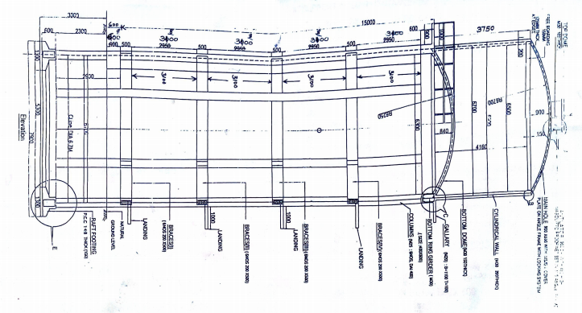

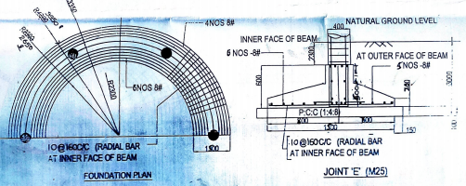

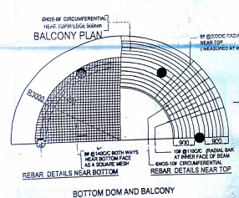

BHANDOLI SITE VISIT FOR INSPECTION
- AREA OF VILLAGE : 15.99KM²
- POPULATION OF VILLAGE : 2308 ( CENSUS 2001)
- ^{DISTRICT : GWALIOR}
- ^{STATE : MADHYA PRADESH}

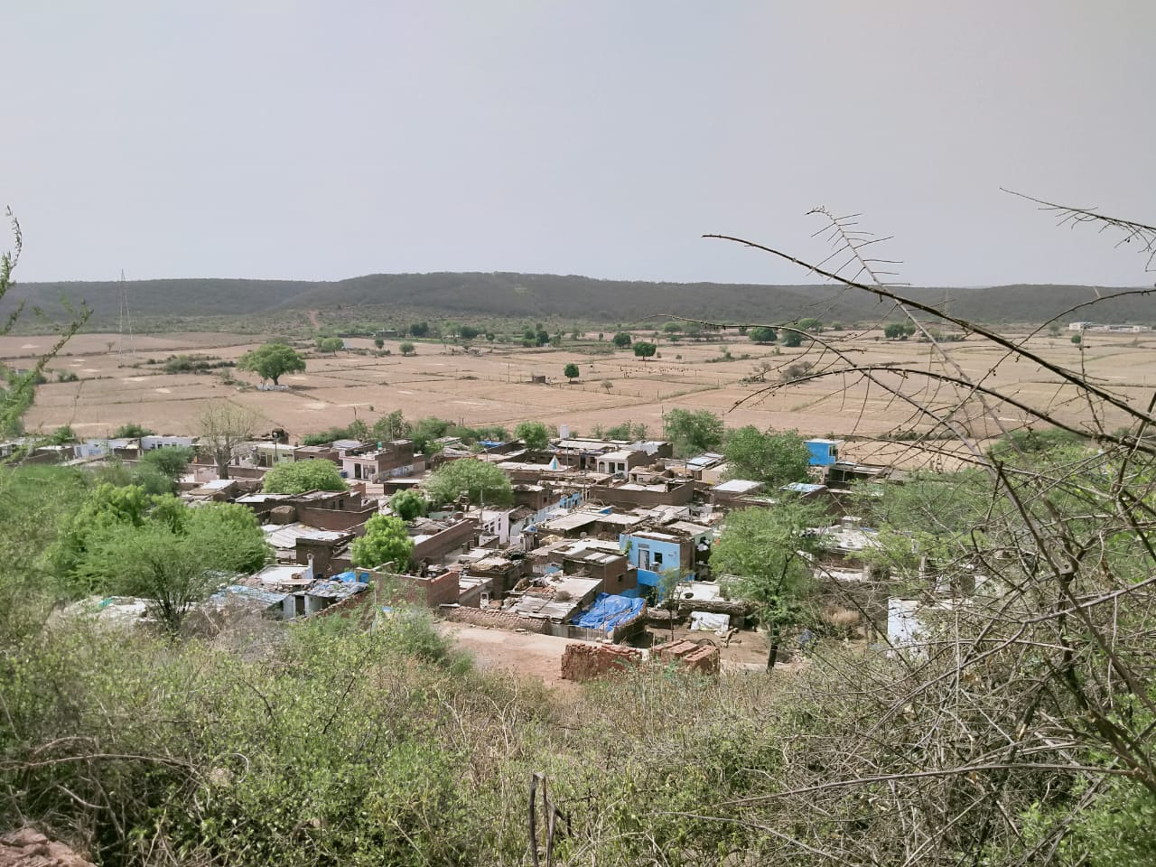

SUMP WELL OF THE VILLAGE
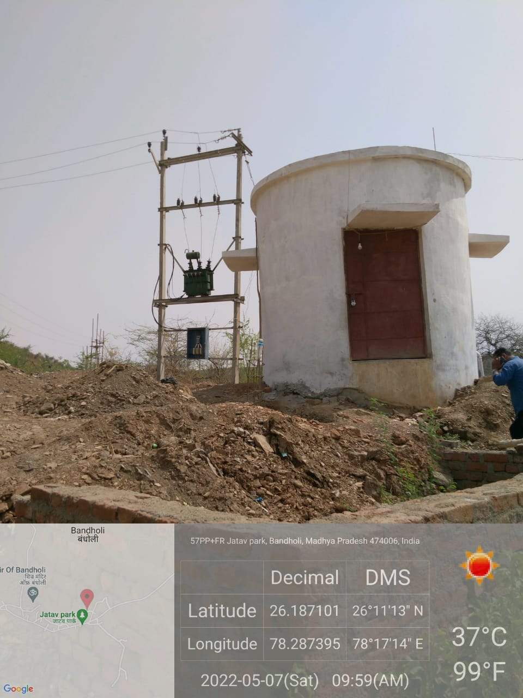

GSR HAVING CAPACITY OF 125KL

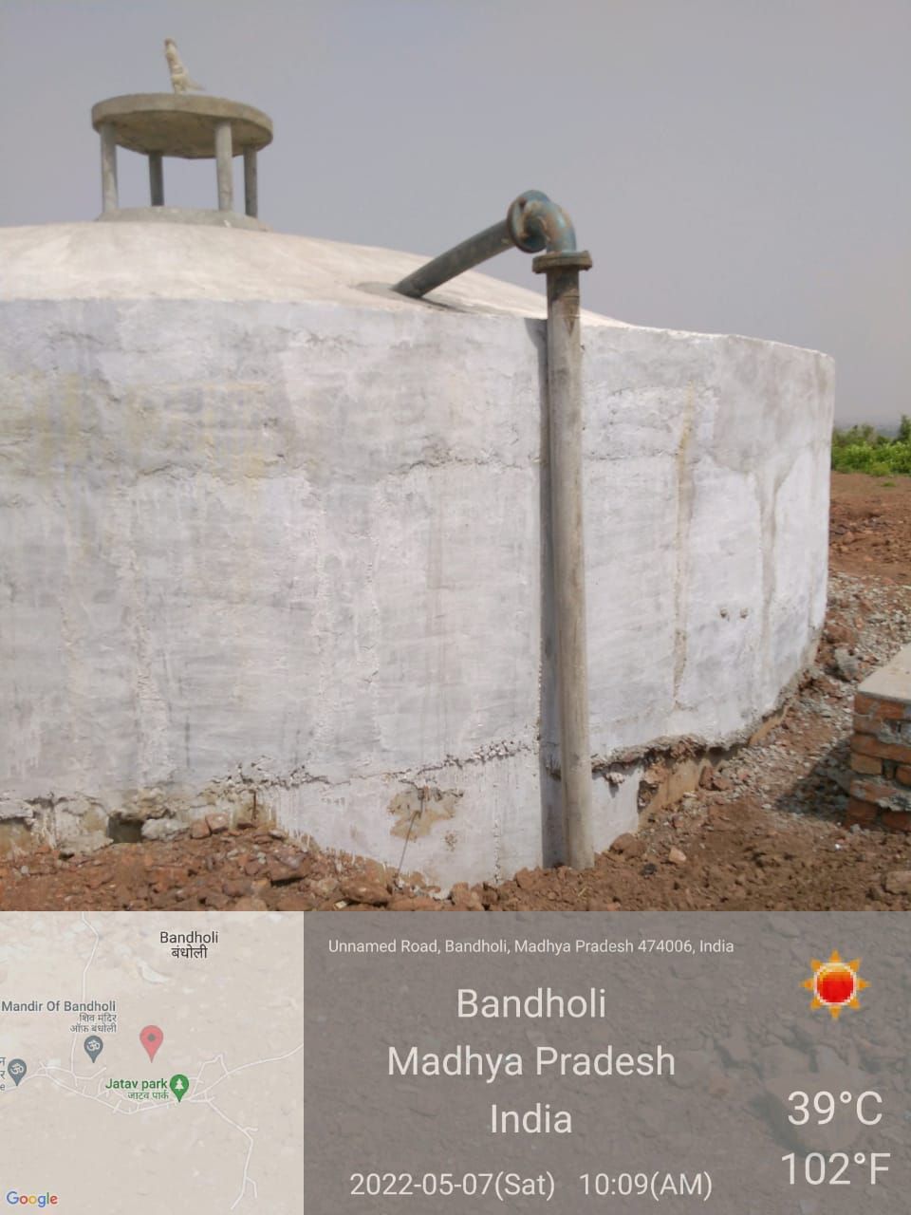

RETROFITTING AND WATER SUPPLY SYSTEM IN BANDHOLI

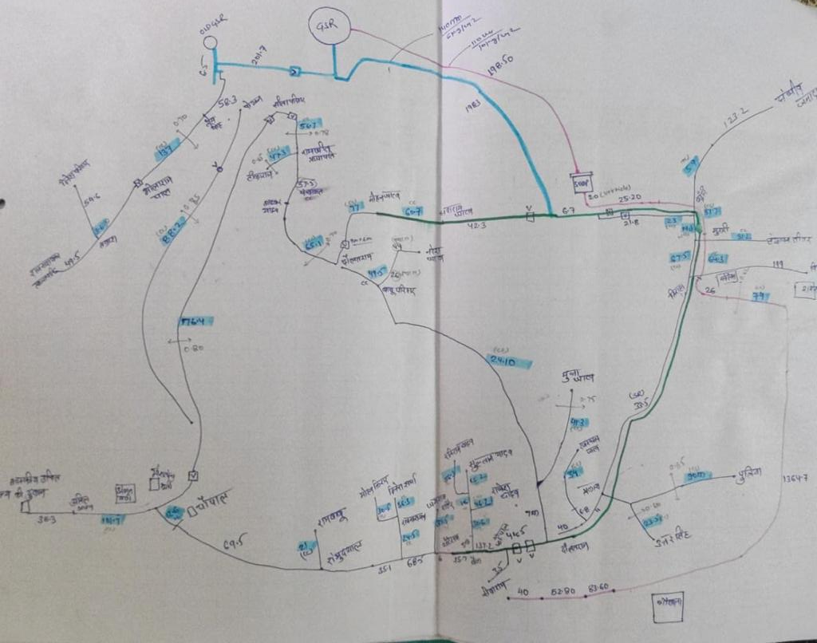

Some Laboratory Reports

GEO–TECHNICAL INVESTIGATION REPORT OF GADROLI VILLAGE
(Soil Test Report)

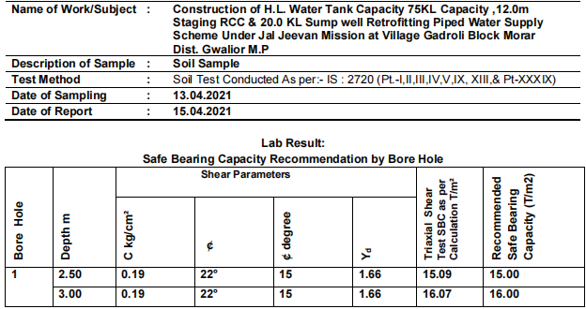

Triaxial Shear Test as per IS: 2720 (Pt-XI)-1993 RA-2002
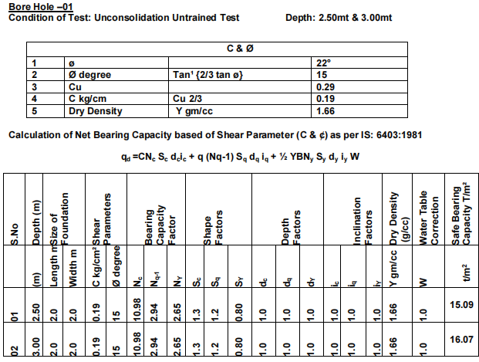

NOTE:-
Where: B= width of strip footing, width of footing side of square footing, diameter of circular footing.
C= Cohesion
Df = Depth of Foundation
N’c N’q N’Y =Bearing Capacity Factor
qult = Net Ultimate Bearing Capacity
ø = Angle of Shearing Resistance of Soil in degree.
Y= Unit Weight of Foundation soil {Dry Density}
Factor of Safety =3.0

DESIGN MIX M-25 - TEST REPORT
@ 7 Day's & 28 Day,s
PROJECT - Construction of H.L. Water Tank Capacity 100KL Capacity ,12.0m Staging RCC & 20.0 KL Sump well Retrofitting Piped Water Supply Scheme Under Jal Jeevan Mission at Village Ghusagava Block Morar Dist. Gwalior M.P

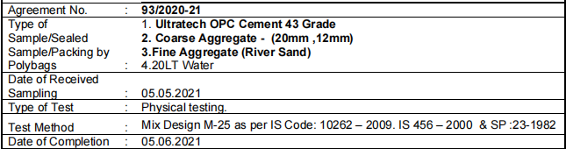

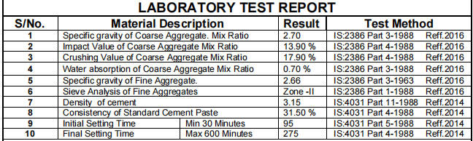
Sieve Analysis of Fine Aggregates Method of Test IS – 2386 2002 ( River Sand)
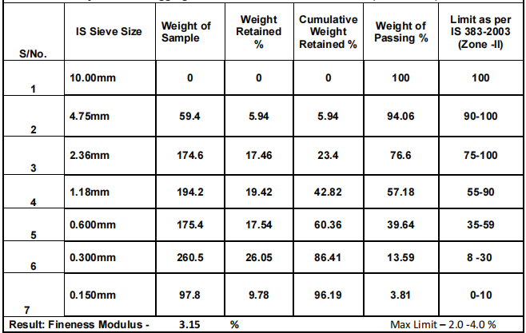

DESIGN MIX M25
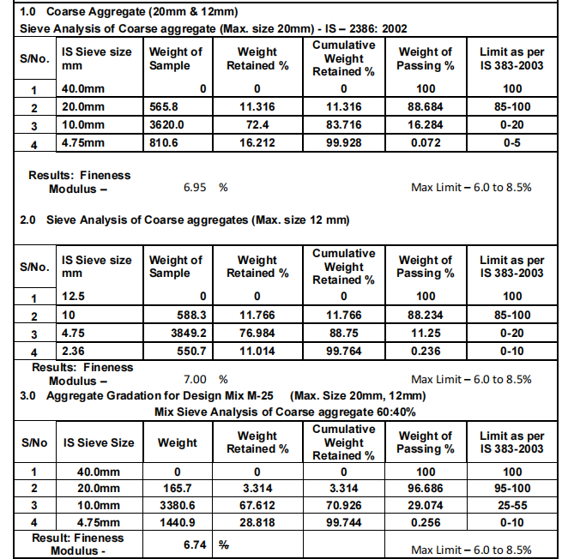
DESIGN MIX M25
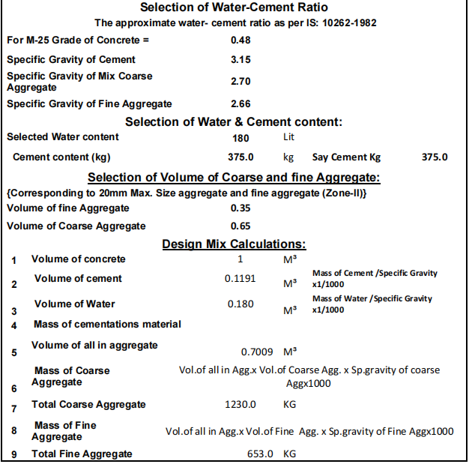

CONCLUSION
The Public Health Engineering Department (T.P.I) built drinking water supply schemes to ensure safe and drinkable drinking water in the state's rural districts, in accordance with the standards of the National Rural Drinking Water Program. Under the JAL JEEVAN MISSION project, drinking ware supply systems have been developed in rural habitations, schools, and anganwadis, with quality control carried out in compliance with government regulations.
1. We work with villages to survey, investigate, design, and construct water supply projects in order to provide safe drinking water.
2. Maintenance and conservation of a Rural Sump well & OHT.
3. In accordance with the state government policy, the implementation and installation of pipe water supply programmes in communities. Arrangements for drinking water in tribal ashrams, anganwadis, and rural schools.
4. Groundwater recharge and enrichment systems, as well as rainfall harvesting schemes, are being implemented to ensure the sustainability of water supply sources.
5.Water quality monitoring and assessment of water sources
6.Completion of the support and concluding tasks.

REFERENCES
1. Bureau of Indian Standards (1970). “IS 1498: Classification and identification soils for general engineering purpose.”
2. Bureau of Indian standards (2720). Part 2: Methods of test for soils Determination of moisture content.”
3. Bureau of Indian standards (1985a). “IS 2720, Part 3: (Sec-1 & 2): Methods of test for soils: Specific gravity.”
4. Bureau of Indian standards (1985a). “IS 2720, Part 4: Methods of test for soils: Grain size analysis.”
5. Bureau of Indian standards (1985a). “IS 2720, Part 5: Methods of test for soils: Atterberg Limit.”
6. Tri- axial shear test.”
7. Bureau of Indian standards (1977). “IS 2720, Part 40: Methods of test for soils: Free swell index.”
8. Bureau of Indian standards (2010). “IS 2911, (Part 1/Sec.2): Methods of test for soils: Code of practice for design & construction of pile foundation (Bored cast in-situ pile).”
9. Text book by DR. A. K. Arora. “.”Soil Mechanics and Foundation Engineering.”
10. Text book by DR. B.C. Punmia, Ashok Kumar Jain & Arun Kumar Jain. “Soil Mechanics and Foundation.”
11. Text book by Narayan V. Nayak. Foundation Design Manual.”

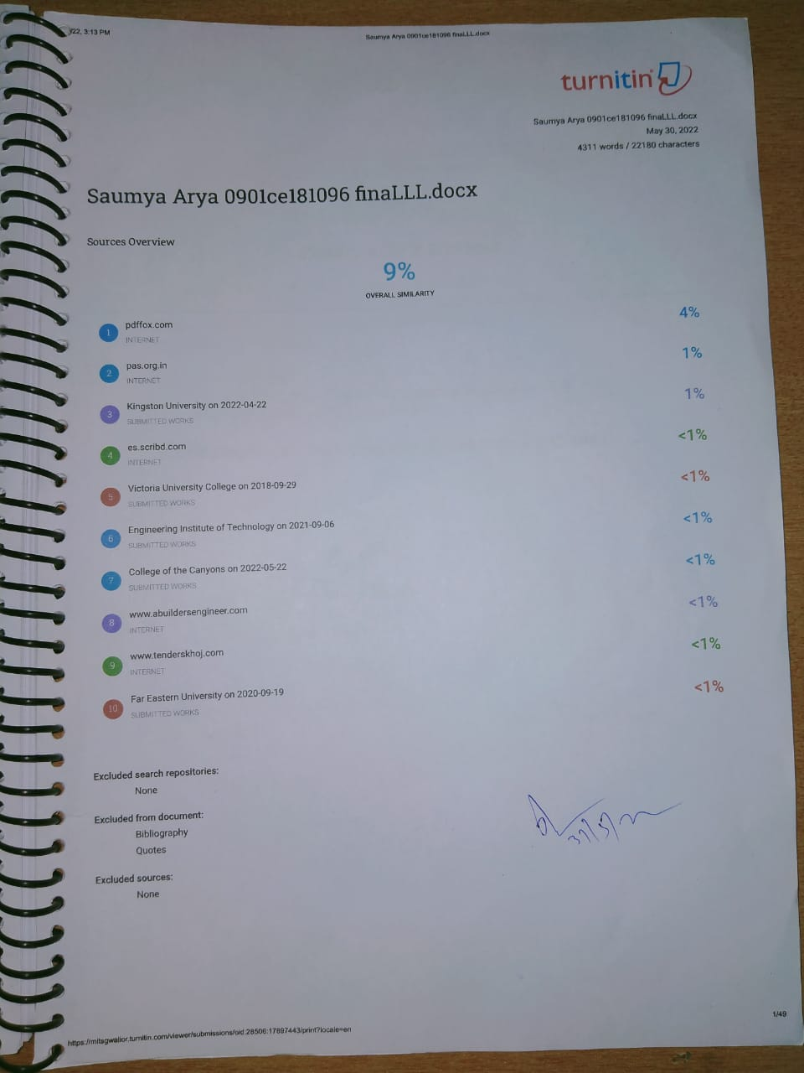

PLAGARISM REPORT
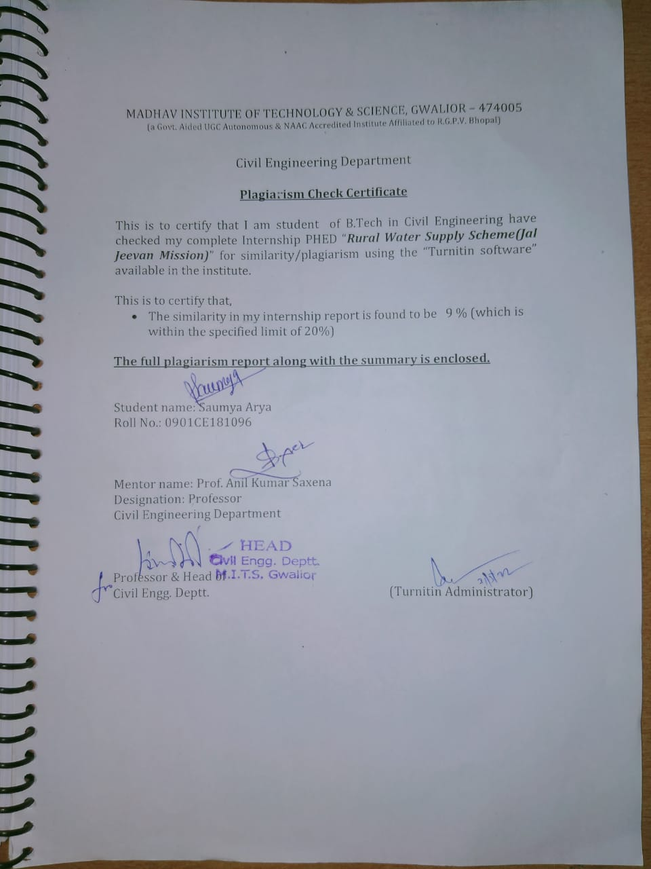
FPR REPORTS
