MADHAV INSTITUTE OF TECHNOLOGY & SCIENCE, GWALIOR
(A Govt. Aided UGC Autonomous & NAAC Accredited Institute Affiliated to RGPV, Bhopal)

Project Report
on
Deep learning based human emotion detection using CNN

A research paper submitted in partial fulfilment of the requirement for the degree of

BACHELOR OF TECHNOLOGY
in
INFORMATION TECHNOLOGY

Submitted by:

Alipt Shrivastava

0901IT181007

Project – 160801

Faculty Mentor
Dr. Dhananjay Bisen
Assistant Professor

Submitted to:

DEPARTMENT OF INFORMATION TECHNOLOGY
MADHAV INSTITUTE OF TECHNOLOGY & SCIENCE
GWALIOR – 474005

MAY-JUNE 2022

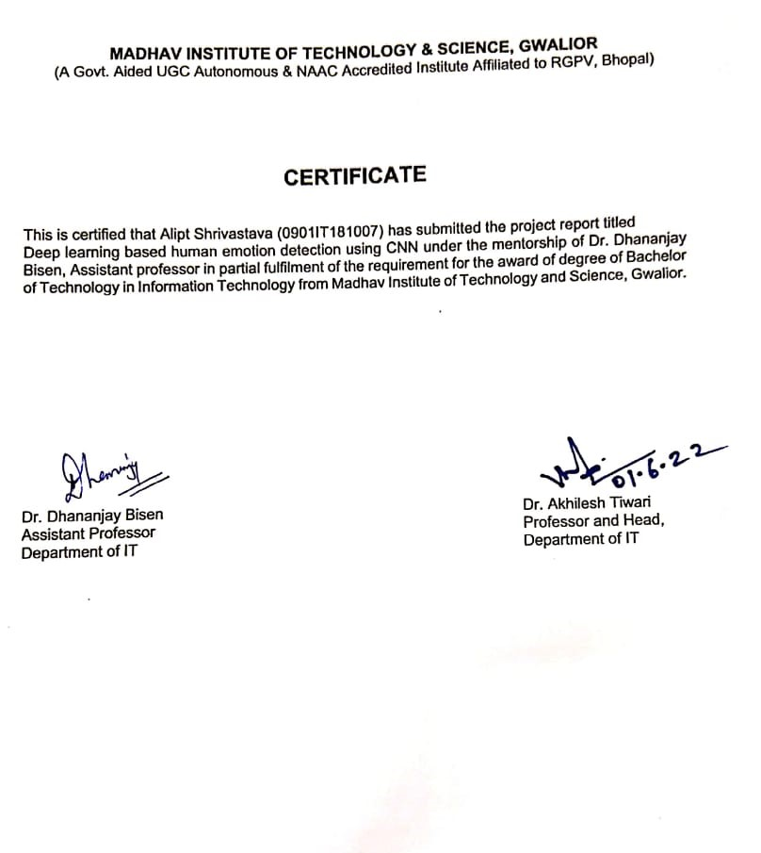

MADHAV INSTITUTE OF TECHNOLOGY & SCIENCE, GWALIOR
(A Govt. Aided UGC Autonomous & NAAC Accredited Institute Affiliated to RGPV, Bhopal)

DECLARATION

I hereby declare that the work being presented in this project report, for the partial fulfilment of
requirement for the award of the degree of Bachelor of Technology in Information Technology at
Madhav Institute of Technology & Science, Gwalior is an authenticated and original record of my
work under the mentorship of Dr. Dhananjay Bisen, Assistant professor, information technology.

I declare that I have not submitted the matter embodied in this report for the award of any degree or diploma anywhere else.



Date:25/05/2022 Alipt Shrivastava
Place Gwalior 0901IT181007
IV Year,
Information Technology

MADHAV INSTITUTE OF TECHNOLOGY & SCIENCE, GWALIOR
(A Govt. Aided UGC Autonomous & NAAC Accredited Institute Affiliated to RGPV, Bhopal)

ACKNOWLEDGEMENT

The full semester project has proved to be pivotal to my career. I am thankful to my institute, Madhav Institute of Technology and Science to allow me to continue my disciplinary/interdisciplinary project as a curriculum requirement, under the provisions of the Flexible Curriculum Scheme (based on the AICTE Model Curriculum 2018), approved by the Academic Council of the institute. I extend my gratitude to the Director of the institute, Dr. R. K. Pandit and Dean Academics, Dr. Manjaree Pandit for this.

I would sincerely like to thank my department, Department of Information Technology, for allowing me to explore this project. I humbly thank Dr. Akhilesh Tiwari, Professor and Head, Department of Information Technology, for his continued support during the course of this engagement, which eased the process and formalities involved.

I am sincerely thankful to my faculty mentors. I am grateful to the guidance of Dr. Dhananjay Bisen, Assistant professor, information technology, for his continued support and guidance throughout the project. I am also very thankful to the faculty and staff of the department.

Alipt Shrivastava
0901IT181007
IV Year,
Information Technology

TABLE OF CONTENTS

PAGE NO.
Abstract 6
List of figures 7
List of tables 7
Chapter 1: Introduction 8
Convolution neural network basic structure 8
Chapter 2: Literature Review 9
Chapter 3: Proposed work 12
Flow Chart 12
Explanation 13
Chapter 6: Results 17
Dataset 1 17
Dataset 2 19
Chapter 8: Conclusion 21
References 22

Abstract:

In this model, A deep learning algorithm of Convolutional neural network is used, which is very effective in image processing as it takes raw input data of image dataset without much pre- processing and gives very accurate results. The first phase of project is to select the datasets to perform the CNN deep learning algorithm in order to recognize emotions on human face. We start the project by importing all the necessary libraries to perform datasets operations, exploratory analysis, evaluation of model, deep learning algorithms and visualization of data. In the next step we extract the image data and put labels on it. Data is then split into train and test data. Train data will be used to train the deep learning model for detection of human emotions. And then the trained model will be used on test data. In the next Step my CNN based deep learning algorithm and all its component are implemented in the python code. After applying this algorithm on multiple data set we have analyzed and visualized its results.

LIST OF FIGURES:

Figure Number Figure caption Page No.
1 basic structure of Convolution neural network 8
2 Simplified Diagram of a neural network 9
3 Flow Chart of model 12
4 Images used in Dataset 13
5 Visual representation of model 16
6 loss and accuracy of dataset 1 17
7 visual representation of accuracy and loss of dataset 17
8 confusion matric generated from the dataset 1 18
9 ROC curve generated from dataset 1 19
10 loss and accuracy of dataset 2 19
11 visual representation of accuracy and loss of dataset 2 19
12 confusion matric generated from the dataset 2 20
13 ROC curve generated from dataset 2 21

LIST OF TABLES

Table Number Table Title Page No.
1 Related work 11
2 Structure and Summary of model 15

Introduction:
A convolutional neural network (CNN) is a type of artificial neural network used in image recognition and processing on pixel data. CNNs are powerful image processing models that use deep learning to perform given tasks such as facial recognition. A neural network is a system of hardware and software patterned after the operations of neurons in the brain. Generally neural networks are not ideal for image processing because they require a lot of pre-processing before feeding data into the neural model. CNN have their “neurons” arranged more like those of the frontal lobe, the area responsible for processing visual stimuli in brain. The layers of CNN model are designed to cover only the part of image containing the information, hence removing the unwanted parts. A CNN model is designed like a multilayer pattern that reduces the processing requirements. The layers of a CNN consist of an input layer, an output layer and hidden layers that includes multiple convolutional layers, pooling layers, fully connected layers and normalization layers. This results in greater efficiency and better results.
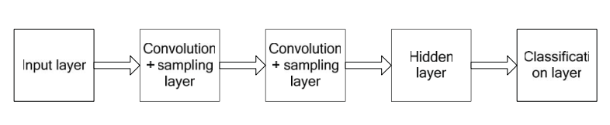
Fig 1: basic structure of Convolution neural network

Convolution neural network basic structure
CNN is artificial neural-network, it is a data model that processes given information just like neurological structure of the brain. Neural network is composed of many neurons; the output of the previous neurons is used as the input of the next neuron. The output is calculated using algebraic equations and appropriate weights and bias. The formula to calculate their values is as follows:
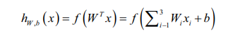
This represents a Logistic regression model. When many neurons are linked together in layered manner the structure obtained is called a neural network model. Figure 1 shows a neural network with hidden layers.
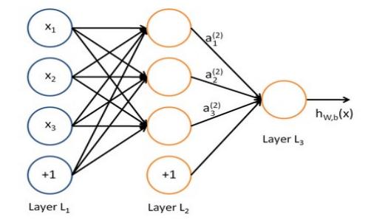
Fig 2: Simplified Diagram of a neural network
In this neural network, x1, x2, x3 are the inputs of the neural network. +1 is the offset node. The first column is the input layer and the final column is the output layer of the neural network. The layers between them are hidden, which are completely connected with the input and the output layers. There are 3 layers in this example. The first layer is marked as L1, then the output layer of the neural network L2, its output layer is L3, Below are the parameters of this neural network.
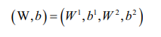
W is the connection parameter between the 2 consecutive layers also known as assigned weight, and b is the offset of the cell of layer. a(i) to represent the output value calculated using weights and offsets of the first few cells of the previous layer. I denote the position of layers. The values of weights are calculated by the process of backward propagation and gradient descent to get desired output a(i).With the set of parameters W and b, we use the formula hw, b(x) to calculate the output of this neural network. f represents sigmoid function which normalize the value of output(a). The following formulas shown are calculation steps:
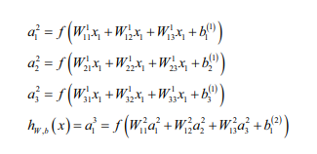
Literature Review:
In this project [1], the author has developed convolutional neural networks (CNN) for a facial expression recognition task. The goal is to classify each facial image into one of the seven facial emotion categories considered in this study. Author developed various CNNs for a facial expression recognition problem and evaluated their performances using different post-processing and visualization techniques. The results demonstrated that deep CNNs are capable of learning facial characteristics and improving facial emotion detection.
As literature [2] mentioned, their study aims to develop a mobile based application for emotion recognition that can recognize emotion based on facial expression in real-time. The Deep Learning based technique, Convolutional Neural Network (CNN) is implemented in this study. The MobileNet algorithm is deployed to train the model for recognition. There are four types of facial expressions to be recognized which are happy, sad, surprise, and disgusting. As the result, this study obtained 85% recognition accuracy. Hence, the implementation of CNN in recognizing emotion successfully achieved promising results and could be able to contributes to the succession work in CNN.
As literature [3] mentioned, Neural network is a statistical learning model inspired by biological neural networks. This paper attempts to use the EEG signal from the DEAP data set to classify the emotion of the subjects, their data set represents the emotional classification research. Then the principal component analysis is used to reduce the dimension of the preprocessed EEG data, so the main emotional EEG features are obtained. Then the accuracy of the classification of the training samples and the test samples is tested by the CNN algorithm, and the other classification methods are compared to obtain the nerves. The average accuracy is 84.3% and 81.2%, but for individual subject, because of the experimental environment, the average classification accuracy was only 63%.The network can be used as a robust classifier for brain signals even better than traditional learning techniques.
As literature [4] mentioned, The primary idea of this project was to process the input images of human facial emotion to train the pre-trained models on datasets. In their project, they approach the problem by taking deep-learning method of Convolutional Neural Networks (CNNs), which integrates the step of handcrafted feature extraction with training of classifier. Their system was able to achieve the relatively most optimal solution through the process of backpropagation in which the algorithm learns the weights through modified stochastic gradient descent that can find the directions that best minimize the loss from the ground truth. They got training accuracy of 55%, and validation accuracy from 55-58% . The result indicates that the trained model has issue of overfitting.
As literature [5] mentioned, This paper has used the Viola-Jones algorithm to detect the eye and lips region from a face and then with the help of the neural network. Also, Machine Learning techniques, Deep Learning models, and Neural Network algorithms are used for emotion recognition. This paper detected emotion from those features from the positioning of the mouth and eyes. This paper will be proposed as an effective way to detect anger, contempt, disgust, fear, happiness, sadness, and surprise. The more epochs they run, the more the model improved, up to a certain point. After that point, the model will stop improving during each epoch. For their model, they set the number of epochs to 3. After 3 epochs, it has gotten to 93% accuracy on that validation set.

Author Name | year | Technique | Review | Result | classes
Punit Prajapati | 2020 | Convolutional Neural Network  With 2 channels | The proposed method in this paper uses 2 channels of Convolutional Neural Network. first channel takes input of face image where second channel is provided with facial parts. | 71%  66% | 5 emotions  7 emotions
J. Jayapradha Soumya Sharma and Yash Dugar | 2019 | tflearn as the frontend, tensorflowas as backend, Convolutional Neural Network, pooling | The main aim of author’s project is to develop a robust system which can detect as well as recognize human emotion from live feed. | 67%  72%  71% | Happy emotion  Neutral emotion  Sad emotion
Ninad Mehendale | 2020 | conventional CNN network module  FERC algorithm | The author has used FERC algorithm, it aims for expressional examination and to characterize the given image into these five essential emotion classes. FERC uses supervised learning and removes background which increase the efficiency and results. | 78%  96% | 2 emotions  2 emotions
Nehmat Sandhu, Aksh Malhotra, Aksh Malhotra | 2020 | Hybrid CNN | In their paper, the authors have used the hybrid CNN approach to recognize human emotions and based upon its features, they are divided into sub-categories. Their research uses a FER13 dataset for emotion recognition. | 88.1%. | 7 emotions
Jie Wang and Zihao | 2018 | theano library, Convolutional Neural Network | In their paper, the convolutional and downsampled layers of CNN are constructed by using the convolution function and downsampling function in opencv to process the pictures. To simplify the CNN model, the convolution and sampling layers are combined into a single layer | 70% | 5 emotions
Table 1: Related work
4.Proposed work:
Flow chart-
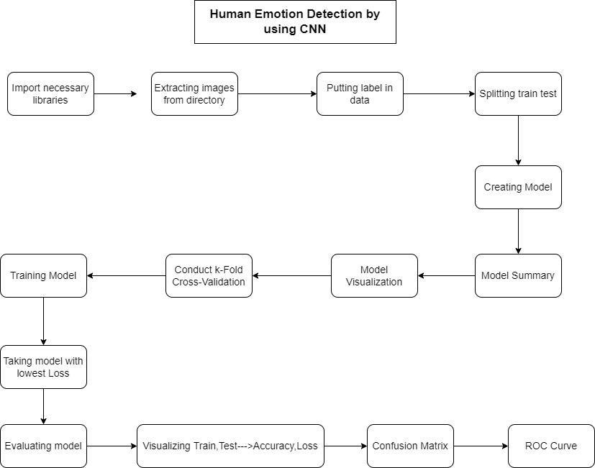
Fig 3: Flow Chart of model

Explanation-
The first phase of project is to select the datasets to perform the CNN deep learning algorithm in order to detect human faces. We have used Dataset 1-FER-2013 and Dataset 2-CK+48 dataset which was available ion Kaggle, these data consists of 48x48 pixel grayscale images of faces. The faces have been automatically registered so that the face is more or less centred and occupies about the same amount of space in each image.
The task is to categorize each face based on the emotion shown in the facial expression into one of seven categories (Angry, Disgust, Fear, Happy, Sad, Surprise, Neutral) in FER-2013 and (Angry, Disgust, Fear, Happy, Sad, Surprise, contempt) in CK+48. The training set consists of 28,709 examples and the public test set consists of 3,589 examples. Below is the picture of dataset input containing images of all 7 human emotions.
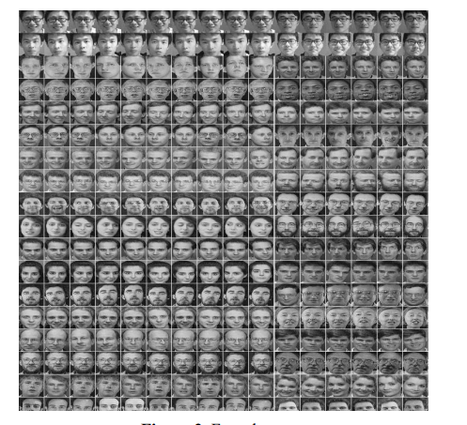
Fig 4: Images used in Dataset

We start the project by importing all the necessary libraries to perform datasets operations, exploratory analysis, evaluation of model, deep learning algorithms and visualization of data. In the next step we extract the image data and put labels on it.
The data is then split into train and test data. Train data will be used to train the deep learning model for detection of human emotions. And then the trained model will be used on test data.
In the next Step our CNN based deep learning algorithm and all its component are implemented in the python code. The first step in development of CNN model was the implementation of input size which is (48,48,3) , here 48,48 represents the dimensions of input data of 48 rows*48 columns and 3 represents the color scheme of RGB used here.
After that we have used Keras.Conv2D Class. Keras Conv2D is a 2D Convolution Layer, this layer creates a convolution kernel that is wind with layers input which helps produce a tensor of outputs.
Mandatory Conv2D parameter is the numbers of filters that convolutional layers will learn from.
It is an integer value and also determines the number of output filters in the convolution.

model.add(Conv2D(6, (5,5), padding="same", activation="relu"))
model.add(MaxPooling2D(pool_size=(2, 2)))

Here we are learning a total of 6 filters and then we use Max Pooling to reduce the spatial dimensions of the output volume. while selecting the best price for number of filters, it is usually advocated to use powers of 2 as the values.
Padding is a term applicable to CNN as it refers to the amount of pixels delivered to an photo when it is being processed through the kernel of a CNN
The padding parameter of the Keras Conv2D magnificence can take one of two values: ‘valid’ or ‘same’. It applies padding to the input image in order that the input image gets fully blanketed by using the filter and exact stride.it is referred to as same due to the fact, for stride 1, the output will be the same as the input. you could keep spatial dimensions of the quantity such that the output quantity size suits the input quantity size, by way of putting the value to the “same”.
The activation parameter to the Conv2D class is virtually a convenience parameter which permits you to deliver a string, which specifies the call of the activation function you need to use after performing the convolution. In a neural network, the activation function is accountable for reworking the summed weighted input from the node into the activation of the node or output for that input.
The rectified linear activation function or ReLU for quick is a piecewise linear function with a purpose to output the input without delay if it is positive, in any other case, it's going to output zero.
In nest step we've got carried out max pooling on input data. Max pooling is a pooling operation that selects the most element from the area of the feature map included via the filter. as a consequence, the output after max-pooling layer might be a feature map containing the maximum distinguished features of the preceding feature map. we have executed max pooling in length of (2,2) in 2 dimensions.
the subsequent step inside the method is called flattening. flattening is used to transform all of the resultant 2-Dimensional arrays from pooled feature maps right into a single lengthy non-stop linear vector. The flattened matrix is fed as input to the completely linked layer to categorise the image.
In subsequent step, we've carried out Dense layer. A dense layer is a layer that is deeply linked with its previous layer this means that the neurons of the layer are related to each neuron of its previous layer. this layer is the maximum generally used layer in artificial neural network networks.
The dense layer’s neuron in a model receives output from every neuron of its previous layer, where neurons of the dense layer perform matrix-vector multiplication. Matrix vector multiplication is a method where the row vector of the output from the previous layers is equal to the column vector of the dense layer. the overall rule of matrix-vector multiplication is that the row vector need to have as many columns like the column vector.
After that created a drop out layer The Dropout layer randomly sets input units to zero with a frequency of rate at each step throughout schooling time, which facilitates prevent overfitting. Inputs now not set to 0 are scaled up by using 1/(1 - rate) such that the sum over all inputs is unchanged.
in the end we compiled the model the usage of model.assemble(). Which uses loss, matrics and optimizers. Loss function is an optimization feature that's utilized in case of training a classification model which classifies the information with the aid of predicting the probability of whether or not the data belongs to at least one class or the other elegance. one of the examples wherein go entropy loss feature is used is Logistic Regression. categorical_crossentropy is used as a loss feature for multi-magnificence class model in which there are or more output labels. The output label is assigned one-hot class encoding cost in shape of 0s and 1. The output label, if present in integer shape, is converted into express encoding the use of keras. Metric features are just like loss capabilities, besides that the consequences from evaluating a metric are not used when training the model. An optimizer is a function or an set of rules that modifies the attributes of the neural network, together with weights and learning fee. therefore, it allows in lowering the overall loss and enhance the accuracy. we have used RMSprop as optimizer right here Optimizer that implements the RMSprop algorithm. The gist of RMSprop is to preserve a moving (discounted) common of the rectangular of gradients. Divide the gradient with the aid of the root of this common. This implementation of RMSprop makes use of undeniable momentum, no longer Nesterov momentum.The centered Version moreover maintains a moving average of the gradients, and uses that common to estimate the variance. eventually we go back the version we've got created. We now get the Model summary, We can use the model.summary() method to visualize the model architecture.
Model: "sequential_1"
_________________________________________________________________
Layer (type) Output Shape Param #
=================================================================
conv2d_1 (Conv2D) (None, 48, 48, 6) 456
_________________________________________________________________
max_pooling2d_1 (MaxPooling2 (None, 24, 24, 6) 0
_________________________________________________________________
conv2d_2 (Conv2D) (None, 24, 24, 16) 2416
_________________________________________________________________
activation_1 (Activation) (None, 24, 24, 16) 0
_________________________________________________________________
max_pooling2d_2 (MaxPooling2 (None, 12, 12, 16) 0
_________________________________________________________________
conv2d_3 (Conv2D) (None, 10, 10, 64) 9280
_________________________________________________________________
max_pooling2d_3 (MaxPooling2 (None, 5, 5, 64) 0
_________________________________________________________________
flatten_1 (Flatten) (None, 1600) 0
_________________________________________________________________
dense_1 (Dense) (None, 128) 204928
_________________________________________________________________
dropout_1 (Dropout) (None, 128) 0
_________________________________________________________________
dense_2 (Dense) (None, 7) 903
=================================================================
Total params: 217,983
Trainable params: 217,983
Non-trainable params: 0
Table 2: Structure and Summary of model

Next step is visualizing the model
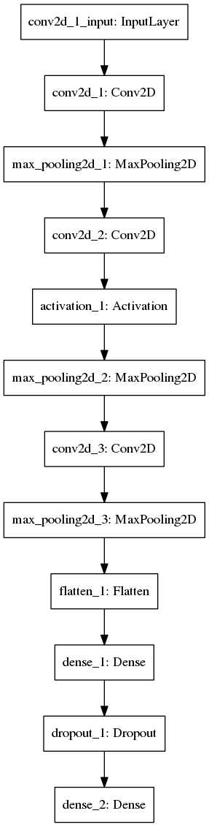
Fig 5: Visual representation of model
After this we conduct K cross validation. Cross-validation, It is used in machine learning model to measure the quality of a machine learning model on unseen dataset. To use a small sample in order to check how the model will perform in general when used to make predictions on dataset different from the training data. After getting all the models, we select the model with the lowest loss to get the best results. In the next step we train the model, we take the model with lowest loss and evaluate its result.
Results: Dataset1
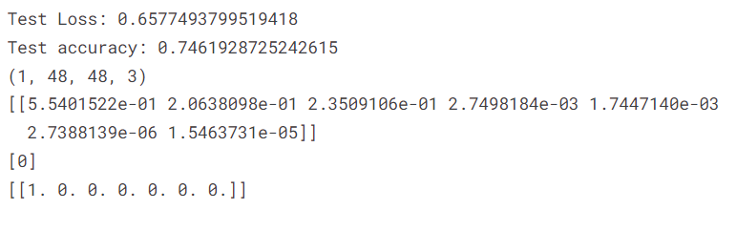
Fig 6: loss and accuracy of dataset 1
After that we evaluate the model and its result, we visualize the accuracy and loss of model.
Loss: loss function is an optimization function which is used in case of training a classification model which classifies the data by predicting the probability of whether the data belongs to one class or the other class.
Accuracy: it is the measure of correct classifications that model is making.
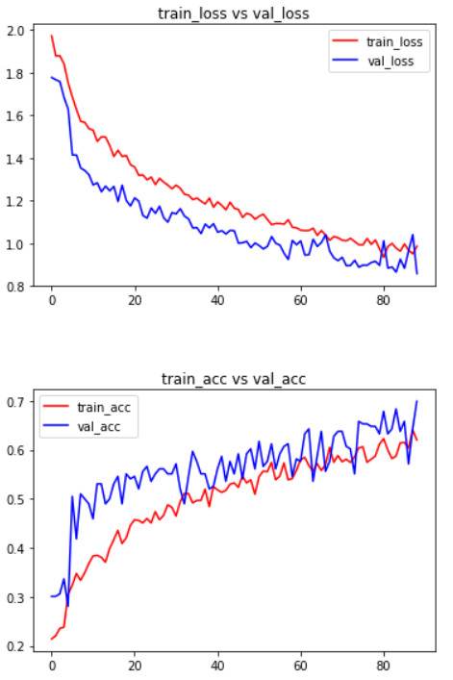
Fig 7: visual representation of accuracy and loss of dataset 1
And observe the confusion matric generated from the model.
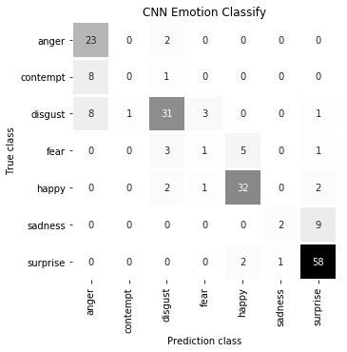
Fig 8: confusion matric generated from the dataset 1
The diagonal elements in a confusion matrix represents the correct classification done by the model, also called true positives and true negatives. Other elements represent wrong classifications made by model such as false positives and false negatives. This is a multivariate confusion matrix containing 7 variables which are human emotions as shown in the above diagram. For example , the bottom last element [58] indicates that our model has classified surprise emotion correctly 58 times. On the other hand the first element of 2nd row [8] indicates that our model has classified contempt as anger 8 times which is a wrong prediction and known as false positive.
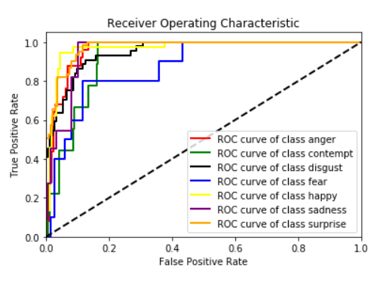
Fig 9: ROC curve generated from dataset 1
ROC Curve-
ROC curve (receiver operating characteristic curve) It is a graph showing the performance of a classification model at all classification thresholds. The curve plot is based on two parameters:
- True Positive Rate
- False Positive Rate
True Positive Rate (TPR): TPR=TPTP+FN
False Positive Rate (FPR) : FPR=FPFP+TN

An ROC curve plot shows True positives rates vs. False positives rates at different classification thresholds. Lowering the classification threshold shows more items as positive, thus increasing both False Positives and True Positives.
Dataset 2
Test Loss: 0.5008549423992331
Test accuracy: 0.8324872851371765
(1, 48, 48, 3)
[[9.8615372e-01 1.3038622e-02 7.8917755e-04 1.0506583e-06 7.9583067e-08
1.6941708e-06 1.5632661e-05]]
[0]
[[1. 0. 0. 0. 0. 0. 0.]]
Fig 10: loss and accuracy of dataset 2

After that we evaluate the model and its result, we visualize the accuracy and loss of our model.
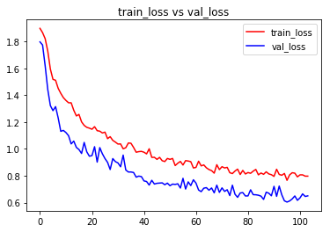
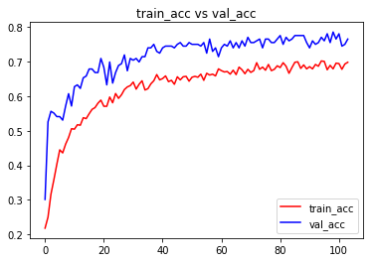
Fig 11: visual representation of accuracy and loss of dataset 2

And observe the confusion matric generated from the model.
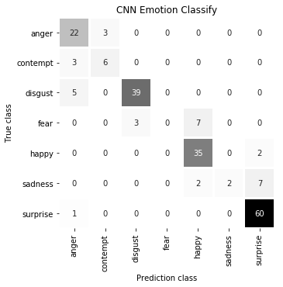
Fig 12: confusion matric generated from the dataset 2

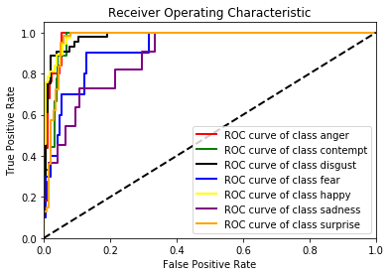
Fig 13: ROC curve generated from dataset 2

Conclusion:
This paper studies the basic structure of CNN, as well as the basic principles of CNN. This model is used to train the face data set to optimize the model parameters. No preprocessing was required ,multiple convolutional layers were used for feature selection and after that filters and padding were used to optimize data and flatten it in I dimension. That I dimensional data is feed to input layers of neural network which after being processed by all the hidden layers give the out put in final layer. After applying this model on 2 different datasets we got results with accuracy of 74.6% and 83.% which makes the argument of using CNN for human emotions detection strong.

References:

[1] Shima Alizadeh and Azar Fazel, Convolutional Neural Networks for Facial Expression Recognition, CoRR, abs/1704.06756, 2017, http://arxiv.org/abs/1704.06756.
[2] Nur Alia Syahirah Badrulhisham and Nur Nabilah Abu Mangshor,Emotion Recognition Using Convolutional Neural Network (CNN),The 1st International Conference on Engineering and Technology (ICoEngTech) 2021,
Journal of Physics: Conference Series, 1962 (2021) 012040 IOP Publishing doi:10.1088/1742-6596/1962/1/012040.
[3] Guolu Cao, Yuliang Ma, Xiaofei Meng, Yunyuan Gao, Ming Meng, Emotion Recognition Based On CNN, Proceedings of the 38th Chinese Control Conference July 27-30, 2019
[4] Lanqing Zhao, Chieh-En LiLanqing Zhao, Chieh-En Li, The Application of CNN on Emotion Recognition, 2019 Purdue Undergraduate Research Conference
[5] Md. Forhad Ali, Mehenag Khatun, Nakib Aman Turzo, Facial Emotion Detection Using Neural Network, International Journal of Scientific & Engineering Research Volume 11, Issue 8, August-2020 ISSN 2229-5518
[6] Punit Prajapati, Sumil Jain, Human Emotion Analysis using Convolutional Neural NetworkHuman Emotion Analysis using Convolutional Neural Network, International Journal of Engineering Research & Technology (IJERT) ISSN: 2278-0181
NTASU - 2020 Conference Proceedings
[7] J. Jayapradha Soumya Sharma and Yash Dugar, Detection and Recognition of Human Emotion using Neural Network, International Journal of Applied Engineering Research, ISSN 0973-4562 Volume 13, Number 8 (2018) pp. 6472-6477
[8] Ninad Mehendale, Facial emotion recognition using convolutional neural networks (FERC), Published online: 18 February 2020 Springer Nature Switzerland AG 2020
[9] Nehmat Sandhu, Aksh Malhotra, Mandeep Kaur Bedi, Human Emotions Detection Using Hybrid CNN Approach, International Journal of Computer Science and Mobile Computing, Vol.9 Issue.10, October- 2020, pg. 1-9
[10] Jie Wang and Zihao Li, Research on Face Recognition Based on CNN, 2nd International Symposium on Resource Exploration and Environmental Science, IOP Publishing IOP Conf. Series: Earth and Environmental Science 170 (2018) 032110 doi :10.1088/1755-1315/170/3/032110

