MADHAV INSTITUTE OF TECHNOLOGY & SCIENCE, GWALIOR (A Govt. Aided UGC Autonomous & NAAC Accredited Institute Affiliated to RGPV, Bhopal)

Project Report
on
Leaf disease identification using deep learning
A project report submitted in partial fulfillment of the requirement for the degree of BACHELOR OF TECHNOLOGY
in
INFORMATION TECHNOLOGY
Submitted by:
Ritesh Tiwari
(0901IT181047)
Faculty Mentor:
Dr. Dhananjay Bisen
Assistant Professor(IT)
Submitted to:
DEPARTMENT OF INFORMATION TECHNOLOGY
MADHAV INSTITUTE OF TECHNOLOGY & SCIENCE
GWALIOR - 474005
MAY-JUNE 2022
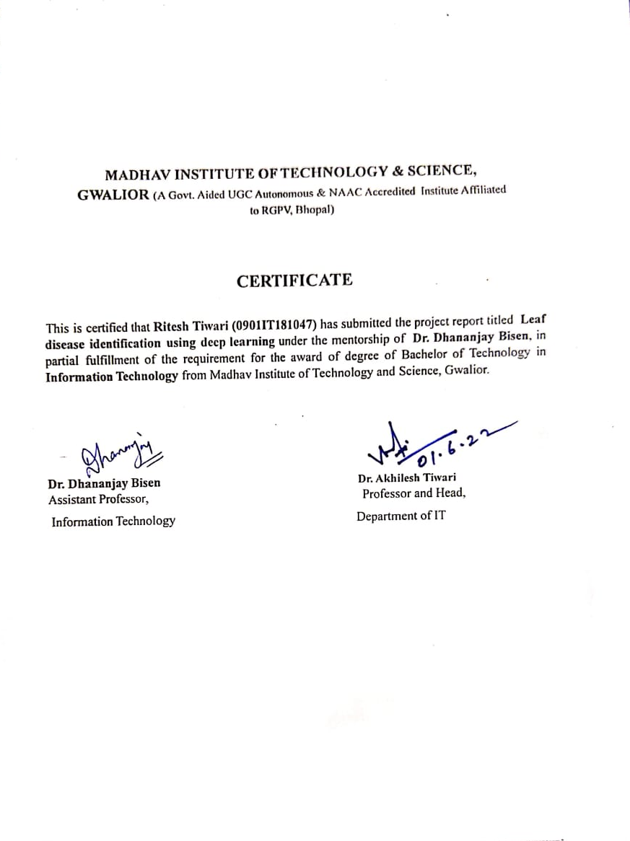

MADHAV INSTITUTE OF TECHNOLOGY & SCIENCE, GWALIOR (A Govt. Aided UGC Autonomous & NAAC Accredited Institute Affiliated to RGPV, Bhopal)
DECLARATION
I hereby declare that the work being presented in this project report, for the partial fulfilment of requirement for the award of the degree of Bachelor of Technology in Information Technology at Madhav Institute of Technology & Science, Gwalior is an authenticated and original record of my work under the mentorship of Dr. Dhananjay Bisen, Assistant Professor, Information Technology.
I declare that I have not submitted the matter embodied in this report for the award of any degree or diploma anywhere else.


Date: 26 .05.2022 Ritesh Tiwari
Place: Gwalior (0901IT181047)
IV Year,
Information Technology

MADHAV INSTITUTE OF TECHNOLOGY & SCIENCE, GWALIOR (A Govt. Aided UGC Autonomous & NAAC Accredited Institute Affiliated to RGPV, Bhopal)
ACKNOWLEDGEMENT
The full semester project has proved to be pivotal to my career. I am thankful to my institute, Madhav Institute of Technology and Science to allow me to continue my disciplinary/interdisciplinary project as a curriculum requirement, under the provisions of the Flexible Curriculum Scheme (based on the AICTE Model Curriculum 2018), approved by the Academic Council of the institute. I extend my gratitude to the Director of the institute, Dr. R. K. Pandit and Dean Academics, Dr. Manjaree Pandit for this.
I would sincerely like to thank my department, the Department of Information Technology, for allowing me to explore this project. I humbly thank Dr. Akhilesh Tiwari, Professor and Head, Department of Information Technology, for his continued support during the course of this engagement, which eased the process and formalities involved.
I am sincerely thankful to my faculty mentors. I am grateful for the guidance of Dr. Dhananjay Bisen, Assistant Professor, Information Technology. for his continued support and guidance throughout the project. I am also very thankful to the faculty and staff of the department.

Ritesh Tiwari
(0901IT181047)
IV Year,
Information Technology

ABSTRACT
Plant leaf diseases affect the growth of plants and also sometimes it can even lead to the death of a plant. Diseased plants also affect the total agricultural production of the country. Identification and detection of diseased plants is a crucial factor in agricultural production and also in the earning of farmers.The best way to identify these plant diseases is by human naked eyes but it is a time consuming process so to overcome these challenges we use different Deep Learning techniques . At present time , machine based plant leaf diseases detection equipment has been applied in agriculture farms and has almost replaced the traditional naked eye identification system.
In recent times the use of deep learning models has increased ,these deep learning models nowadays are used to solve daily problems. Some of the important uses of these models are face Recognition,disease detection, traffic detection , expression recognition ,etc.
To develop these deep learning model it requires large number of dataset(in millions) then these raw dataset is trained , the training time for these models are quite high .In this research work I tried to reduce training time by reducing the size of dataset from millions to few thousand without compromising with my model accuracy.

TABLE OF CONTENTS
PAGE NO.
Abstract 5
List of figures 7
List of tables 8

Chapter 1: Introduction 9
Chapter 2: Related Work 10
Chapter 3: Material and methods 13
3.1 what is data science 13
3.2 Deep learning 13
3.3 CNN- Convolutional Neural Networks 14
3.4 CAE - Convolutional Autoencoder 15
3.4.1 How Data compression is performed via autoencoders ? 17
Chapter 4: Proposed work 21
Chapter 5: Dataset description 25
Chapter 6: Result 26
Chapter 7: Summary of various research work 28
Chapter 8: Conclusion and future directions 29
Funding 30

Declaration of conflicting interests 30

References 30

LIST OF FIGURES
Figure Number Figure caption Page No.
1 CNN architecture 14
2 General polling 14
3 The basic layers of CNN 15
4 Convolutional Autoencoder 17
5 Data points 18
6 Architecture of linear autoencoder 20
7 Flow-diagram of proposed method 22
8 Healthy rice leaf image 25
9 Images of black spot diseased rice leaf 25
10 proposed model loss 27
11 proposed model accuracy 28

LIST OF TABLES

Table Number Table Title Page No.
1 Summary of techniques and comparison between 11
studies for classification plant diseases.
2 Layer wise details of the model 23-24

3 Summary of various research work 29

1.Introduction
India is also known as agriculture land.India has evolved from food deficient country to surplus food country. Current status of food grain production in India is around three times that of buffer stock norms. In the early nineteen sixties India was an import dependent nation , few major steps (the green revolution in the 1960s ,intensive use of inputs and technological advancement)taken by India have made India a global agricultural powerhouse. Although the share of agriculture has been declining in overall gross value added (GVA) of India, it continues to grow in absolute terms and employs almost 41.49 % of total employment in 2020( World Bank collection of development indicators).Therefore disease free grain production is essential for the growth of the country's economy.Timely and accurate diagnosis of plant diseases is important for high agriculture production as diseased plants can directly affect income of farmers . Traditionally these detection of plant disease is done manually by farmers but it can take several weeks to cover acres of land , therefore to save crucial time of farmers Nowadays technology is used to detect plant diseases. Also they can provide us promising results .Today a number of models presented by researchers to detect diseased plants using deep learning algorithms such as Convolutional Neural Networks ,Recurrent Neural Networks,etc.

2.Related Work
In this section we will discuss the ideas of other researchers across the globe who have explored different Deep Learning and Image Processing techniques to automate plant leaf disease detection. Some of the techniques are present in this paper that is used for automatic plant leaf disease detection. M Afonso et al.- 2019 proposed a non destructive method which was based on ResNet -18 to identify blackleg disease of potato plants . Sanga et al.- 2020 proposed a disease detection model for banana plants with five different CNN architectures. These architectures were VGG-16, ResNet-152, ResNet-50, ResNet-18, and InceptionV3. In their model they found that ResNet-152 outperformed others with an accuracy of 99.2%.B. Jiang et al. -2018 proposed a model to detect tomato diseases and pests, for Maize using Super-Pixel and GLCM for feature extraction and SVM for classification. Yunong Tian et al-2019 proposed a model to detect an apple during different growth stages in orchards using YOLO-V3 network processed by the DenseNet method. Alina Forster et al.-2019 used a hyperspectral microscope to capture hyperspectral images of barley leaves, and then used CycleGAN to forecast the spread of disease symptoms on barley plants.
G Zhou et al.-2016 proposed a method for detecting rapid rice disease based on fuzzy c-means and k-means and Faster R-CNN.
Mohanty et al. analyzed -2016 designed a system using AlexNet and GoogLeNet CNN architectures' for plant leaf disease detection using the PlantVillage dataset. They performed sixty different experiments with the help of sixty different configurations. They found that GoogLeNet with transfer learning outperformed with an accuracy of 99.30%. The number of training parameters was around seven million.Pardede et al.- 2018 designed a system for automatic disease detection for corn and potato plants with CAE and SVM classifiers . They have taken images of corn and potato plants from the PlantVillage dataset. They achieved 80.42% and 87.01% accuracy respectively .Wan-jie Liang et al.-2019 proposed a rice blast disease detection method using the concept of deep learning.In there model they compared four different types of recognition method (CNN,CNN+SVM,LBPH+SVM,Haar-WT+SVM) they found that CNN outperformed others with an accuracy of 95.83%.My approach is based on recent work by Punam Bedi et.al -2021 which showed for the first time by reducing dimensionality of images we can reduce the size of dataset from millions to few thousands.

Author and Year | CNN Architecture | Number of Images | Accuracy
Fujita, E. et al. -2016 | Customized | 14840 | 82.32%
Wang, G. et al.- 2017 | VGG 16 ,VGG 19 ,Inception V3, Residual Network (ResNet) 50 | 2086 | 90.4%
Khandelwal, I. et al. -2018 | Inception V3 , ResNet 50 | 86,198 | 99.37%
DeChant, C. et al. —2017 | Customized | 1796 | 96.70%
Brahimi, M. et al. —2017 | AlexNet ,GoogleNet | 14,828 | 99.18%
Brahimi, M. et al. 2018 | AlexNet ,DenseNet 169 ,Inception V3 ,ResNet 34, SqueezeNet 1.1 ,VGG 13 | 54,323 | 99.76%
Lu, Y. et al. -2017 | AlexNet | 500 | 95.48%
Kawasaki, Y. et al.—2015 | Customized | 800 | 94.90%
Tabel 1-Summary of techniques and comparison between studies for classification plant diseases.

3. Material and methods
This section discusses the material and methods which are used to design the model. In this section we will understand the basics of Data Science , Deep learning , convolutional neural networks(CNN )and Convolutional Autoencoder( CAE), which is helpful to understand the proposed work.

3.1 What Is Data Science ?
Data science is the branch of science that deals with bulk volumes of data by using modern tools and techniques. It uses different machine learning techniques to find patterns which can lead to some useful information, which later can be used to make important decisions.
Today Data science is an important part of many organizations, the large amounts of data that are produced, are converted into meaningful information. Its popularity is growing day by day , and industries and companies have realized its importance and started implementing data science techniques to grow their business and increase customer satisfaction.

3.2 Deep learning
The concept of Deep Learning originated from a paper published in Science by Hinton et al. in 2006.
It is “a machine learning technique that teaches the computers to do what comes naturally to humans”.
Deep Learning is a subfield of Machine Learning, which is a subfield of Artificial Intelligence. Artificial Intelligence(AI ) refers to techniques that help computers or robots to behave like human behavior and think like a human intelligent brain. Machine Learning represents a set of algorithms trained on data that make all of this possible.
Deep Learning techniques are preferred over the Machine Learning techniques because deep learning techniques reduce the amount of processing time . Also extraction of different useful features from raw data are done automatically.Deep learning uses a multi-layered structure of algorithms called neural networks which enables us to perform many tasks, such as regression, classification,clustering ,regression ,etc.

3.3 CNN- Convolutional Neural Networks
In 1995, Yann LeCun and Yoshua Bengio introduced the concept of convolutional neural networks.“A simple CNN is a sequence of layers, and every layer of a CNN transforms one volume of activations to another through a differentiable function.” Convolutional neural networks are mainly used in face recognition, handwriting translation and other image and video processing tasks.
Basic layer of CNN is shown in fig -3
It consists of mainly 3 sequences of layers.
- Convolutional Layer -It is a major building block of CNN. It consists of a set of learnable filters .Every filter is small in size , but extends through the full depth of the input volume (fig 1).

Input layer
Convolutional layer
Pooling layer
Fully connected layer

Output layer
fig -1-CNN architecture
- Pooling Layer- This layer helps in reducing the amount of parameters(as shown in fig -2). It extracts a specific value (max operation value) from a given set of values, which reduces the size of the output matrix. Pooling Layer play an important role in controlling the overfitting.

- 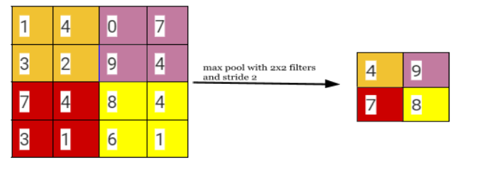
fig 2- general polling
- FullyConnected Layer- Fully Connected layer(FC) is the last layer of the CNN architecture before the output layer(as shown in fig -2,-3). In Fully Connected layer neurons have full connections to all activations in the previous layer. It connects neurons in one layer to neurons in another layer.

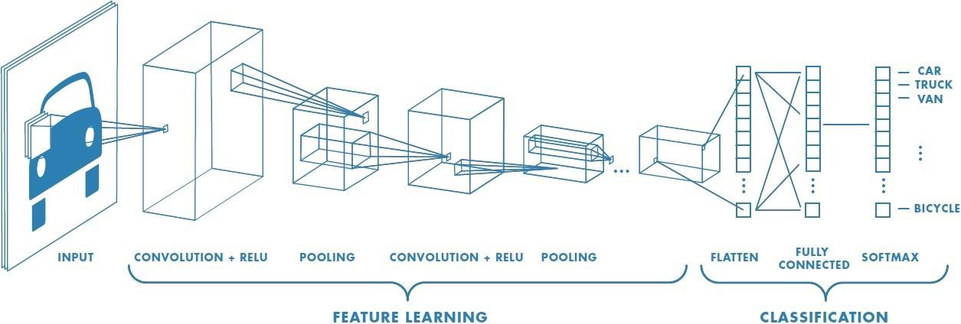
fig 3 -The basic layers of CNN.
Reference of image3 -https://medium.com/@himadrisankarchatterjee/a-basic-introduction-to-convolutional-neural-network-8e39019b27c4

3.4 CAE - Convolutional Autoencoder
Autoencoders are neural networks used in unsupervised learning, in order to perform data compressing(fig -4). The input is compressed in a latent-space representation and we try to reconstruct the input from this representation. Convolutional Neural Networks are very successful in image recognition. The shared parameters make the CNNs scale to high-dimensional problems and outperforms fully-connected neural networks.
Here, Convolutional Auto-encoders use the scaling abilities of convolutional layers in order to perform dimensionality reduction.
The success of the CAE will be tested as follows:
- By the representation learning capabilities of your model. In particular, autoencoders are known to be able to learn quite informative features in their latent space (embeddings) that can later be used for downstream tasks. We will use the representations in order to do image classification.
- By the autoencoders' reconstruction error. We will need to achieve a low enough error in order to reconstruct the images of the dataset with relatively high fidelity. We will look at the model's training loss curve, reconstruction error on the test set and some reconstructed images in the respective cells.

There are many interesting applications of autoencoders , such as data compression, visualization, etc. But researchers observed that autoencoders could be used as a way to “pretrain” neural networks.
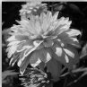

flatten
FC
Conv 1
Conv 2
Conv 3
DeConv 2
DeConv 3
Reshape
h
DeConv 1
fig -4- Convolutional Autoencoder

3.4.1 How Data compression is performed via autoencoders ?
Suppose that I would like to write a program to send some data from my smartphone to the cloud. Since I want to limit my network usage, I will optimize every bit of data that I am going to send. The data is a collection of data points, each has two dimensions. A sample of my data look like the following:
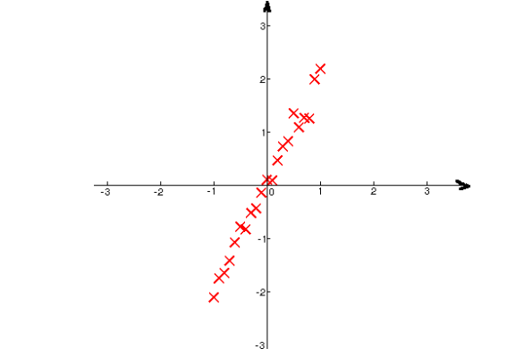
Fig 5 data points
Here, the red crosses (in fig 5) are my data points, the horizontal axis is the value of the first dimension and the vertical axis is the value of the second dimension. Upon visualization, I notice that the value of the second dimension is approximately twice as much as that of the first dimension. Given this observation, we can send only the first dimension of every data point to the cloud. Then at the cloud, we can compute the value of the second dimension by doubling the value of the first dimension. This requires some computation, and the compression is lossy, but it reduces the network traffic by 50%. And since network traffic is what I try to optimize, this idea seems reasonable. So far this method is achieved via visualization, but the bigger question is can we do this more systematically for high-dimensional data? More formally, suppose we have a set of data points {$x^{1},$$x^{2}$, , ..., $x^{m}$} where each data point has many dimensions. The question becomes whether there is a general way to map them to another set of data points {$z^{1},$$z^{2}$, , ..., $z^{m}$}, where z’s have lower dimensionality than x’s and z’s can faithfully reconstruct x’s.
To answer this, notice that in the above process of sending data from my smartphone to the cloud has three steps:
1. Encoding: in my smartphone, map my data $x^{i}$ to compressed data $z^{i}$ .
2. Sending: send $z^{i}$ to the cloud.
3. Decoding: in the cloud, map from my compressed data $z^{i}$ back to ${\underline{x}}^{ i}$, which approximates the original data. To map data back and forth more systematically, I propose that z and $\underline{x}$ are functions of their inputs, in the following manner:
$z^{i}$ = W1$x^{i}$ + b1 ${\underline{x}}^{ i}$
$x^{i}$= W2 $z^{i}$+ b2
If $x^{i}$ is a two-dimensional vector, it may be possible to visualize the data to find W1, b1 and W2, b2 analytically as the experiment above suggested. Most often, it is difficult to find those matrices using visualization, so we will have to rely on gradient descent. As our goal is to have ${\underline{x}}^{ i}$ to approximate $x^{i}$ , we can set up the following objective function, which is the sum of squared differences between ${\underline{x}}^{ i}$ and $x^{i}$ :
S(W1, b1, W2, b2) = $\sum_{i=1}^{m}{}$${( {\underline{x}}^{ i}- x^{i})}^{2}$
=$\sum_{i=1}^{m}{}$${(w2z^{i}+b2- x^{i})}^{2}$

which can be minimized using stochastic gradient descent. This particular architecture is also known as a linear autoencoder, which is shown in the following network architecture(in fig 6)
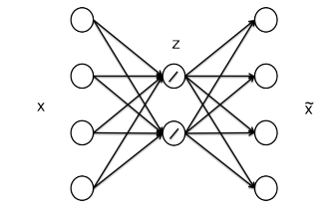
fig 6 architecture of linear autoencoder
In the above figure, we are trying to map data from 4 dimensions to 2 dimensions using a neural network with one hidden layer. The activation function of the hidden layer is linear and hence the name linear autoencoder
Autoencoders belong to a class of learning algorithms known as unsupervised learning. Unlike supervised algorithms, unsupervised learning algorithms do not need labeled information for the data. In other words,our data only have x’s but do not have y’.

4. Proposed work
In this research work, I have designed a model which detects plant leaf diseases automatically. A model for automatic plant leaf disease detection is proposed by many researchers in their respective research papers based on different machine /deep learning algorithms. In my model I have successfully tried to combine two different deep learning techniques: CAE and CNN.
In this research paper they follow a few steps to find accurate results for this proposed model. First step , the CAE network has been trained to reduce the dimensionality of the input leaf images. Then the dimensionality reduction of the leaf images has been done such that the important features of the leaf images are not lost. Which has been minimized by applying the upper limit on Re-construction Loss of CAE. After reducing the dimensionality of leaf images, the output of the Encoder Network of CAE, is used as input to the CNN. With the help of CNN, the input leaf image has been classified as either a diseased leaf or a healthy leaf. the flow-diagram to demonstrate the proposed methodology has been shown in fig.7
The process of designing the proposed hybrid model comprises two steps. The first step is creating a CAE network that reduces the dimensionality of the input leaf images from 256 × 256 to 32 × 32.
Details of CAE architecture is given in table -2
The CAE network also contains a Decoder Network that is used to reconstruct the original data from the encoded data. The training of the CAE network is done such that the Re-construction Loss is minimized as minimum as possible . This ensures that the CAE network reduces the dimensionality of the plant leaf images without losing its important features.

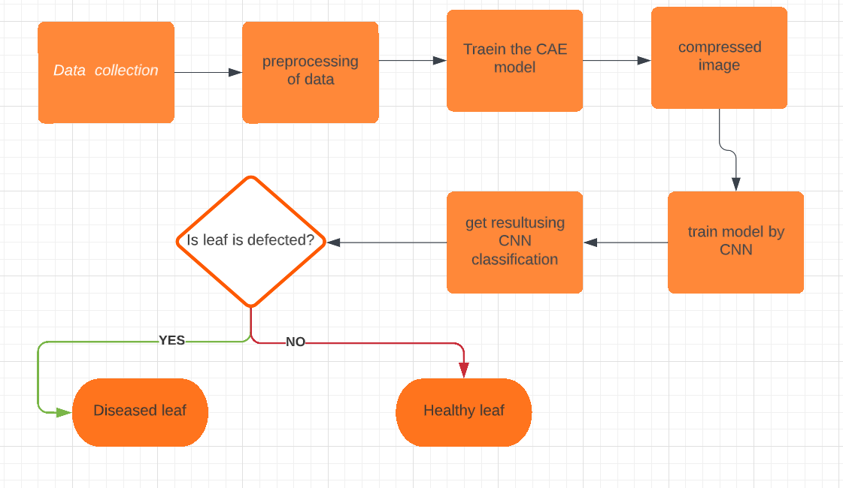
Fig 7. Flow-diagram of proposed method

In this research paper, I used the Normalized Root Mean Squared Error loss function to calculate the Loss between the original plant leaf image and the new plant leaf images (i.e which were reconstructed after) . The formula to compute Normalized Root Mean Squared Error is
NRMSE(OL,RL)=$\frac{\sqrt{\frac{1}{N}\sum_{I=1}^{N}{}{(OL-RL)}^{2}}}{Imax- Imin}$ Eq-1
where OL =original leaf image,
RL= reconstructed leaf image reconstructed,
N = total number of Plant leaf images taken into considerationImax=maximum
pixel intensity Imin = minimum pixel intensity

Layer no. | Type of layer | Input size | Activation function | Number of channels | size of channels | Output size
1 | Input Layer | 256 × 256 × 3 |  | 3 |  | 256 × 256 × 3
2 | Conv 1 | 256 × 256 × 3 | ReLu | 8 | 3× 3 | 256 × 256 × 8
3 | MaxPool 1 | 256 × 256 × 8 |  | 8 | 2× 2 | 128 × 128 × 8
4 | Conv 2 | 128 × 128 × 8 | ReLu | 8 | 3× 3 | 64 × 64 × 8
5 | MaxPool 2 | 128 × 128 × 8 |  | 8 | 2× 2 | 64 × 64 × 8
6 | Conv 3 | 64 × 64 × 8 | ReLu | 8 | 3× 3 | 32 × 32 × 8
7 | MaxPool 3 | 64 × 64 × 8 | - | 8 | 2× 2 | 32 × 32 × 8
8 | Bottleneck Layer | 32 × 32 × 8 | ReLu | 8 | 3 × 3 | 32 × 32 × 8
9 | Conv 7 | 32 × 32 × 8 | ReLu | 6 | 3 × 3 | 30 × 30 × 6
10 | MaxPool 4 | 30 × 30 × 6 | - | 6 | 2 × 2 | 15 × 15 × 6
11 | Conv 8 | 15 × 15 × 6 | ReLu | 16 | 3 × 3 | 13 × 13 × 16
12 | MaxPool 5 | 13 × 13 × 16 | - | 16 | 2 × 2 | 4 × 4 × 16
13 | Conv 9 | 6 × 6 × 16 | ReLu | 16 | 3 × 3 | 4 × 4 × 16
14 | MaxPool 6 | 4 × 4 × 16 |  | 16 | 2 × 2 | 2 × 2 × 16
15 | Flatten Layer | 2 × 2 × 16 |  |  | - | 64
16 | Dense 1 | 64 | ReLu |  |  | 32
17 | Dense 2 | 32 | Sigmoid |  |  | 1
Tabel 2-Layer wise details of the model
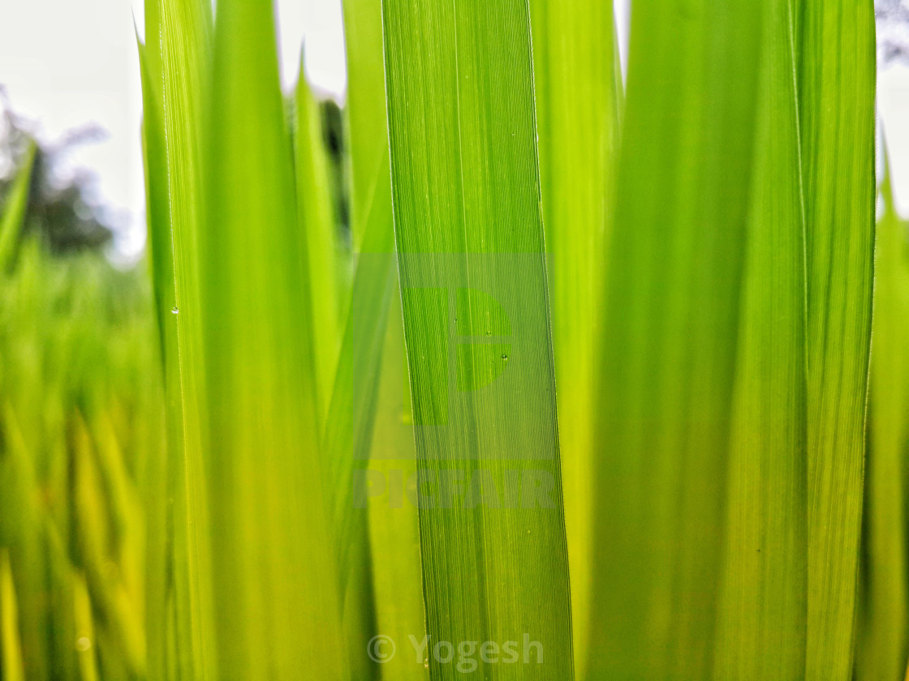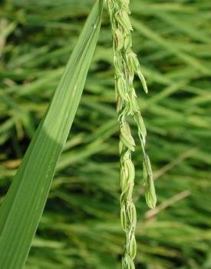

Fig 8-Healthy rice leaf image(above 2 image )
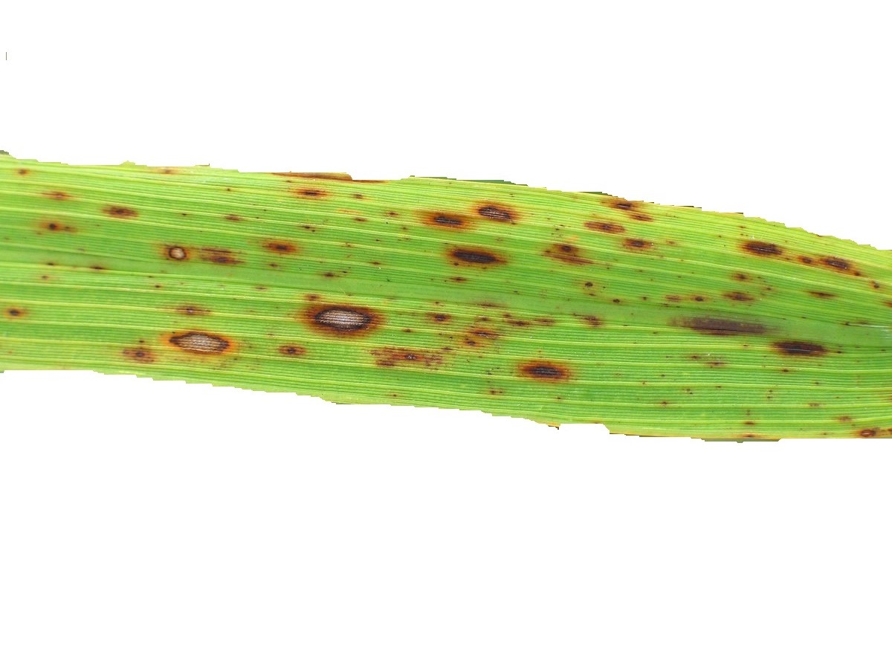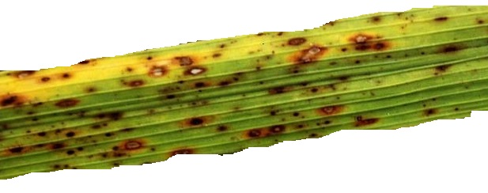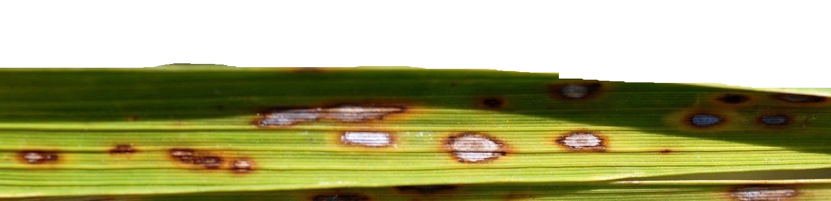
Fig 9 Images of black spot diseased rice leaf(above 3 images)

5. Dataset description
The proposed model has been applied to detect Black Spot disease in rice plants. The leaf images of rice plants have been extracted from the Rice leaf dataset ( https://archive.ics.uci.edu/ml/datasets/Rice+Leaf+Diseases#) ,some examples of a healthy and a diseased leaf image of a rice plant leaf is shown in Fig. 8.and fig 9
For the training of proposed model I split the dataset in 75% as training dataset and 25 % as testing dataset
. Thus, the training dataset has 642 leaf images, and the testing dataset has 215 leaf images.

6.Result
In this paper I proposed a model which is trained on a few thousand parameters which give training accuracy 91.4% and testing accuracy 90.1%.This model has also achieved precision of 90.19% ,recall of 90.57% and F1 score of 90.38%.The Normalized Root Mean Squared Error loss is also calculated as given in equation 1 with help of new plant leaf (i.e after applying cae)and original plant leaf (i.e before applying cae ). The train and test Normalized Root Mean Squared Error loss for new plant leaf images and original plant leaf are 0.09, 0.079 respectively.The advantage of my proposed model is that it takes less time and low computation power to detect diseased plants . The model proposed in this research paper has less accuracy then other proposed models which have millions of training parameters and requires large computational power and more time for prediction of diseased leaf.
Some of other model with high accuracy are as follows
Sanga et al. (2020) with Proposed approach of ResNet-152 uses 60 million of training parameters with testing accuracy 99.2%.Ferentinos (2018) with Proposed approach of VGGNet uses 138 million of training parameters with testing accuracy 99.5%.Mohameth et al. (2020) with Proposed approach of ResNet-50 + SVM uses 25 million of training parameters with testing accuracy 98%.Chohan et al. (2020) with Proposed approach of VGG-19 uses 143 million of training parameters with testing accuracy 98%.

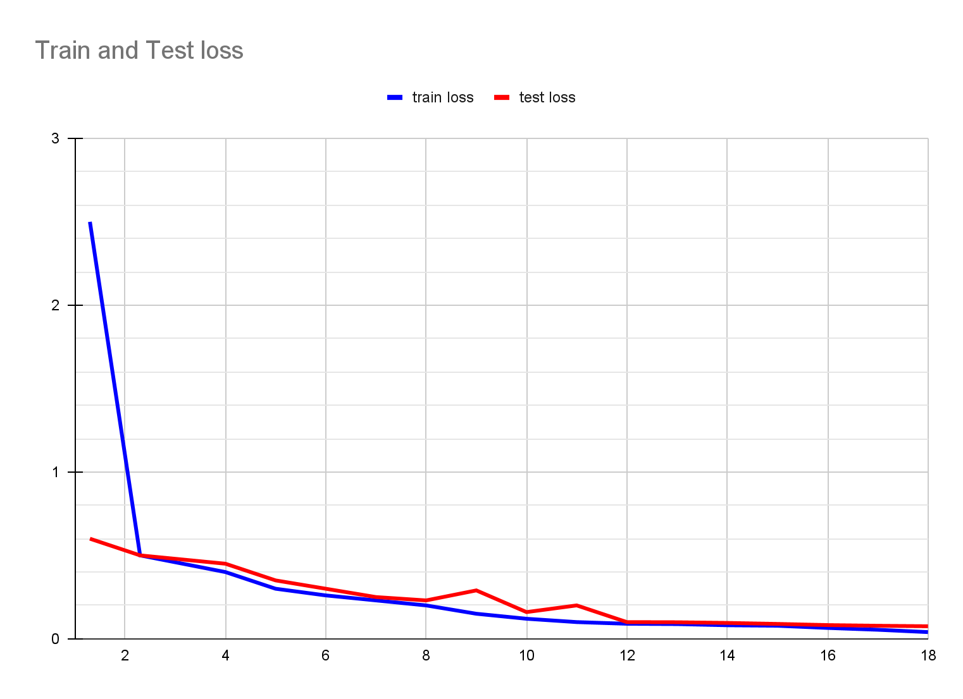
Fig-10 proposed model loss

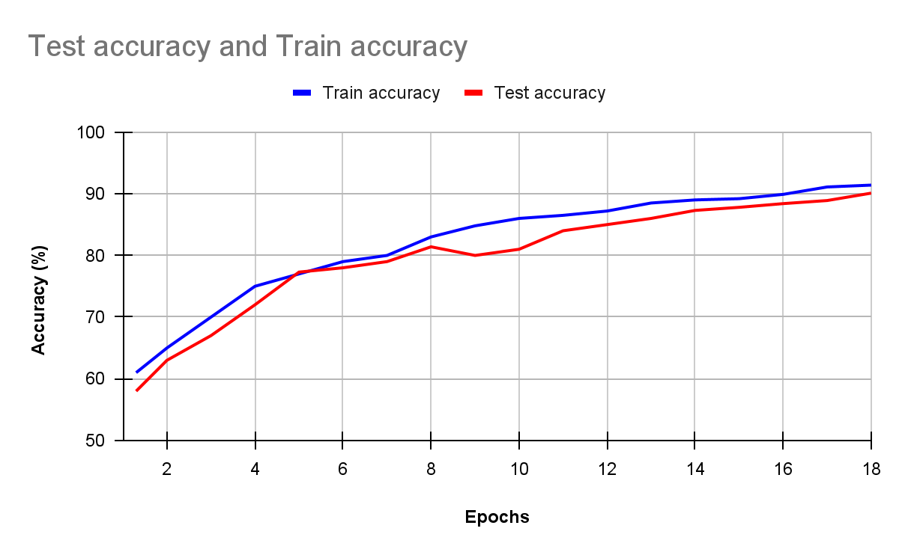
Fig -11 proposed model accuracy

7. Summary of various research work
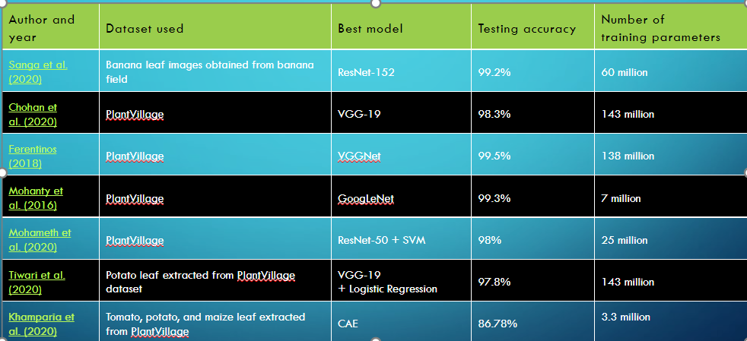
Tabel -3

8. CONCLUSION AND FUTURE DIRECTIONS
In this paper, I have introduced the basic knowledge of deep learning and presented a review of recent research work that I have done and implemented on plant leaf disease detection models using deep learning. Data is available for training and testing of various deep learning techniques and are capable of recognizing leaf diseases with high accuracy .
The importance of collecting large datasets with high variability, data augmentation, transfer learning, and visualization of CNN activation maps in improving classification accuracy, and the importance of small sample plant leaf disease detection and the importance of hyper-spectral imaging for early detection of plant disease.

Funding
This research did not receive any specific grant from funding agencies in the public, commercial, or not-for-profit sector.

Declaration of conflicting interests
The author declared no potential conflicts of interest with respect to the research, authorship, and/or publication of this article.

References
Mhanty, S.P., Hughes, D.P., Salathé, M., 2016. Using deep learning for image-based plant disease detection. Front. Plant Sci. 7, 1–10.
- https://doi.org/10.3389/fpls.2016.01419.
- Naik, M.R., Sivapagari, C.M.R., 2016. Plant leaf and disease detection by using HSV features and SVM classifier. Int. J. Eng. Sci. 6 (12), 1–4.
- Ngugi, L.C., Abelwahab, M., Abo-Zahhad, M., 2020. Recent advances in image processing techniques for automated leaf pest and disease recognition – a review. Inform. Proc. Agric., 1–25.
- https://doi.org/10.1016/j.inpa.2020.04.004.
- Padol, P.B., Yadav, A.A., 2016. SVM classifier based grape leaf disease detection, in: 2016 Conference on Advances in Signal Processing (CASP). IEEE, Pune, India, pp. 175–179 https://doi.org/10.1109/CASP.2016.7746160.
- Panda, Panigrahi Kshyanaprava, Himansu, Das, Kumar, Sahoo Abhaya, Chandra, Moharana Suresh, 2020. Maize leaf disease detection and classification using machine learning algorithms. Progress in Computing. Analytics and Networking. Springer Singapore, Singapore, pp. 659–669.
- https://doi.org/ 10.1109/IC3INA.2018.8629518
- Pedregosa, F., Varoquaux, G., Gramfort, A., Michel, V., Thirion, B., Grisel, O., Blondel, M., Prettenhofer, P., Weiss, R., Dubourg, V., Vanderplas, J., Passos, A., Cournapeau, D., Brucher, M., Perrot, M., Duchesnay, E., 2011. Scikit-learn: machine learning in Python. J. Mach. Learn. Res. 12, 2825–2830. Qin, F., Liu, D., Sun, B., Ruan, L., Ma, Z., Wang, H., 2016. Identification of alfalfa leaf diseases using image recognition technology. PLoS One 11 (12), 1–26. https://doi.org/ 10.1371/journal.pone.0168274
- Saikawa T, Cap QH, Kagiwada S, et al. AOP: an anti overfitting pretreatment for practical image-based plant diagnosis. In: Proceedings of the 2019 IEEE international conference on big data (Big Data), Los Angeles, CA, 9– 12 December 2019, pp.5177–5182. New York: IEEE.. Zhang S, Zhang S, Zhang C, et al.
- Cucumber leaf disease identification with global pooling dilated convolutional neural network. Comput Electron Agr 2019; 162: 422–430. 14. Pixia D and Xiangdong W. Recognition of greenhouse cucumber disease based on image processing technology. Open J Appl Sci 2013; 3(1): 27–31
- Mai G, Cao K, Yuen PC, et al. On the reconstruction of face images from deep face templates. IEEE T Pattern Anal 2019; 41(5): 1188–1202.
- Khanna A and Kaur S. Evolution of Internet of Things (IoT) and its significant impact in the field of Precision Agriculture. Comput Electron Agr 2019; 157: 218–231.
- Jiang M, Rao Y, Zhang J, et al. Automatic behavior recognition of group-housed goats using deep learning. Comput Electron Agr 2020; 177: 105706.
- P. Ghamisi, J. Plaza, Y. Chen, J. Li, and A. J. Plaza, ‘‘Advanced spectral classifiers for hyperspectral images: A review,’’ IEEE Geosci. Remote Sens. Mag., vol. 5, no. 1, pp. 8–32, Mar. 2017.
- ] C. Xie, Y. Shao, X. Li, and Y. He, ‘‘Detection of early blight and late blight diseases on tomato leaves using hyperspectral imaging,’’ Sci. Rep., vol. 5, no. 1, pp. 1–11, Nov. 2015.
- A. Signoroni, M. Savardi, A. Baronio, and S. Benini, ‘‘Deep learning meets hyperspectral image analysis: A multidisciplinary review,’’ J. Imag., vol. 5, no. 5, p. 52, May 2019Comput. Sci., vol. 4, pp. 18–32, Jul. 2020.
- Y. Sun, Z. Jiang, L. Zhang, W. Dong, and Y. Rao, ‘‘SLIC_SVM based leaf diseases saliency map extraction of tea plant,’’ Comput. Electron. Agricult., vol. 157, pp. 102–109, Feb. 2019.
- Z.-W. Hu, H. Yang, J.-M. Huang, and Q.-Q. Xie, ‘‘Fine-grained tomato disease recognition based on attention residual mechanism,’’ J. South China Agricult. Univ., vol. 40, no. 6, pp. 124–132, Jul. 2019. .
- V, Acharjya DP and Bodhwani U. Deep residual networks for plant identification. Procedia Comput Sci 2019; 152: 186–194.
- Forster A, Behley J, Behmann J, et al. Hyperspectral plant disease forecasting using generative adversarial networks. In: Proceedings of the IGARSS 2019 – 2019 IEEE international geoscience and remote sensing symposium, Yokohama, Japan, 28 July–2 August 2019, pp.1793– 1796. New York: IEEE. 36. Sun R, Zhang M, Yang K, et al. Data enhancement for plant disease classification using generated lesions. Appl Sci 2020; 10(2): 466.
- Zhang S, Wang H, Huang W, et al. Plant diseased leaf segmentation and recognition by fusion of superpixel, Kmeans and PHOG. Optik 2018; 157: 866–872.
- . Bai X, Li X, Fu Z, et al. A fuzzy clustering segmentation method based on neighborhood grayscale information for defining cucumber leaf spot disease images. Comput Electron Agr 2017; 136: 157–165. He K, Wang D, Tong M, et al. An improved GrabCut on multiscale features. Pattern Recogn 2020; 103: 107292.
- Al-Qizwini , Barjasteh I, Al-QassabH,Al-Qizwini , et al. Deep learning algorithm for autonomous driving using GoogLeNet. In: Proceedings of the 2017 IEEE intelligent vehicles symposium (IV), Los Angeles, CA, 11–14 June 2017, pp.89–96. New York: IEEE.
- Vanhoucke V, Ioffe S, et al. Rethinking the inception architecture for computer vision. In: Proceedings of the IEEE conference on computer vision and pattern recognition (CVPR), Las Vegas, NV, 27–30 June 2016, pp.2818–2826. New York: IEEE.
- . Zhang. Z and Peng. H. Deeper and wider Siamese networks for real-time visual tracking. In: Proceedings of the IEEE/CVF conference on computer vision and pattern recognition (CVPR), Long Beach, CA, 15–21 June 2019, pp.4591–4600. New York: IEEE
- A. . Singh, B. Ganapathysubramanian, S. Sarkar, and Ak. Singh, ‘‘Deep learning for plant stress phenotyping: Trends and future perspectives,’’ Trends Plant Sci., vol. 23, no. 10, pp. 883–898, Oct. 2018.
- N. Sharma, and S. Singh, ‘‘A review of imaging techniques for plant disease detection,’’ Artif. Intell. Agricult., vol. 4, pp. 229–242, Oct. 2020
- A.-Chai, B.-J. Li, Y.-X. Shi, Z.-X. Cen, H.-Y. Huang, and J. Liu, ‘‘Recognition of tomato foliage disease based on computer vision technology,’’ Acta Horticulturae Sinica, vol. 37, no. 9, pp. 1423–1430, Sep. 2010.
- Punam Bedi, Pushkar Gole “Plant disease detection using hybrid model based on convolutional autoencoder and convolutional neural network” on 11 May 2021.
- Z. R. Li and D. J. He, ‘‘Research on identify technologies of apple’s disease based on mobile photograph image analysis,’’ Comput. Eng. Des., vol. 31, no. 13, pp. 3051–3053 and 3095, Jul. 2010.
- J. G. A. Barbedo, ‘‘Factors influencing the use of deep learning for plant disease recognition,’’ Biosyst. Eng., vol. 172, pp. 84–91, Aug. 2018.
- A. Kamilaris and F. X. Prenafeta-Boldú, ‘‘Deep learning in agriculture: A survey,’’ Comput. Electron. Agricult., vol. 147, pp. 70–90, Apr. 2018.
- G. L. Grinblat, L. C. Uzal, M. G. Larese, and P. M. Granitto, ‘‘Deep learning for plant identification using vein morphological patterns,’’ Comput. Electron. Agricult., vol. 127, pp. 418–424, Sep. 2016.

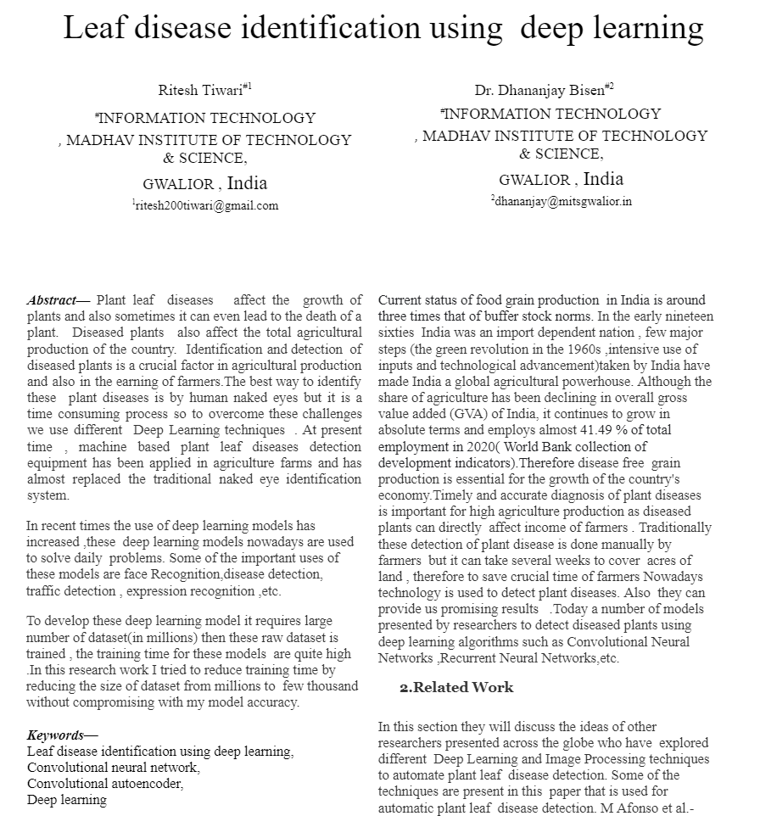

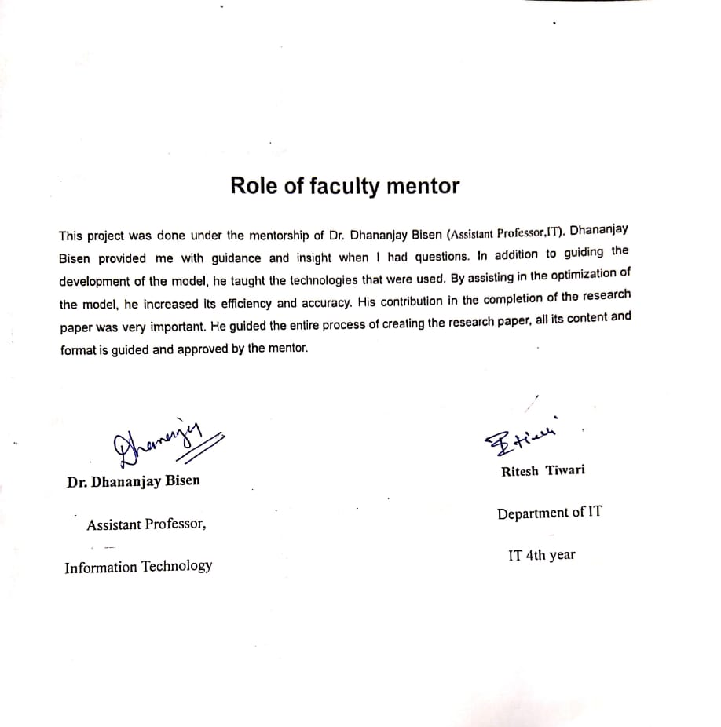

Plagiarism report of paper
